Section 1:
Objectives:
- Move resource values to a separate file as variable blocks.
- Update main Terraform file to use variables.
- Validate, deploy, expand, analyze, and destroy infrastructure.
Part 2: Update vars03s1.tf File
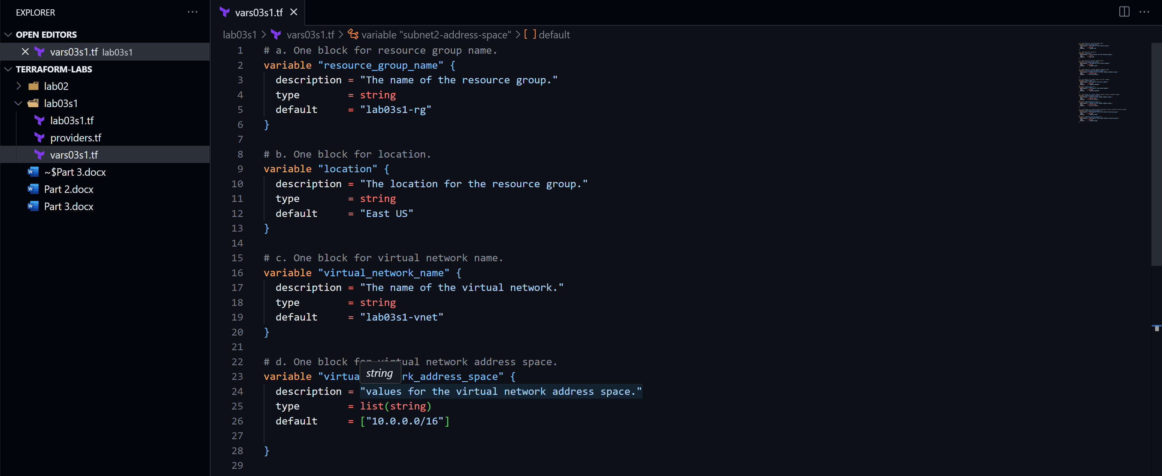
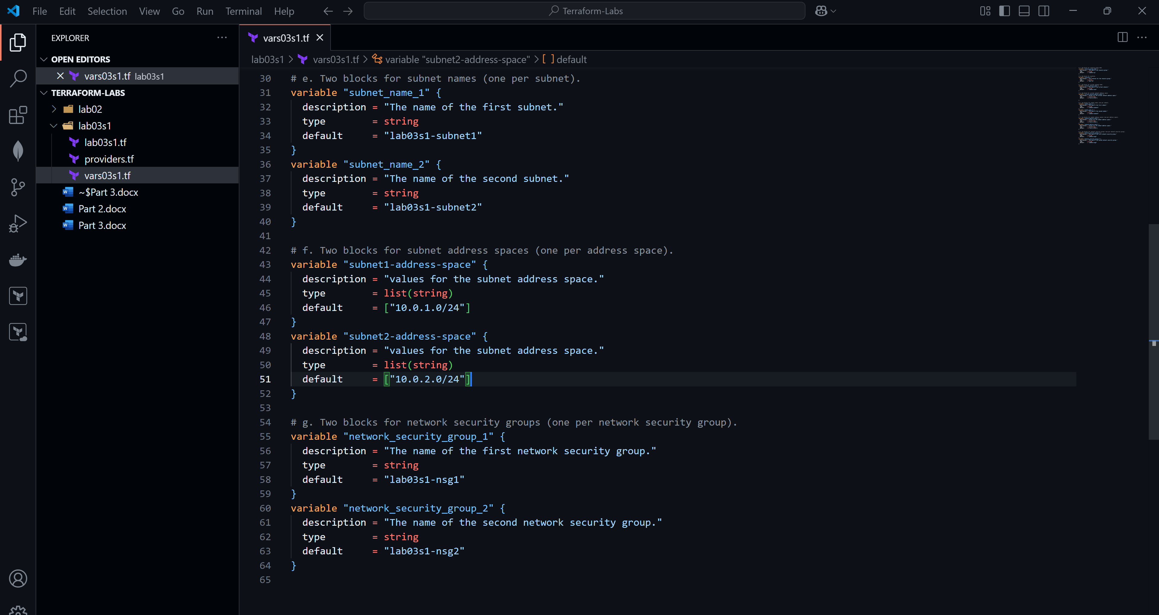

Part 3: Update lab03s1.tf File
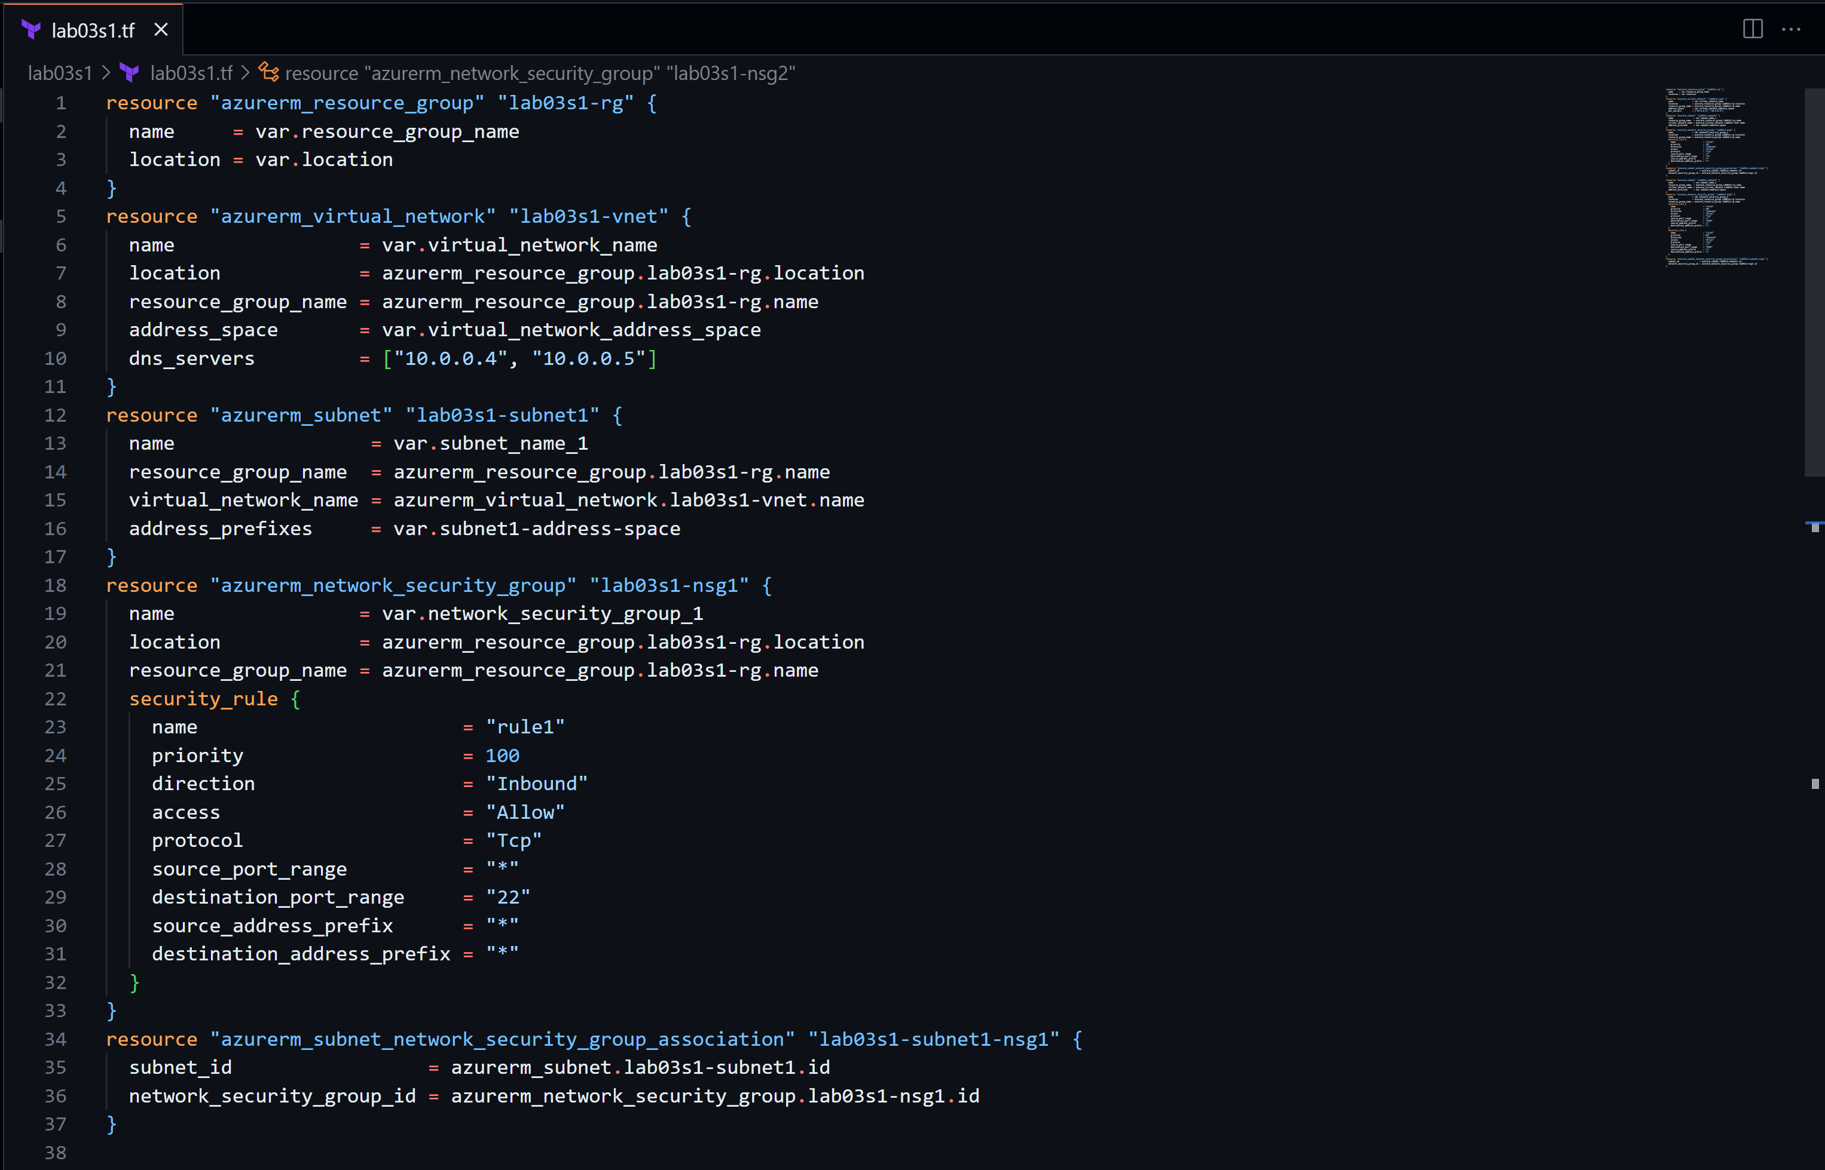
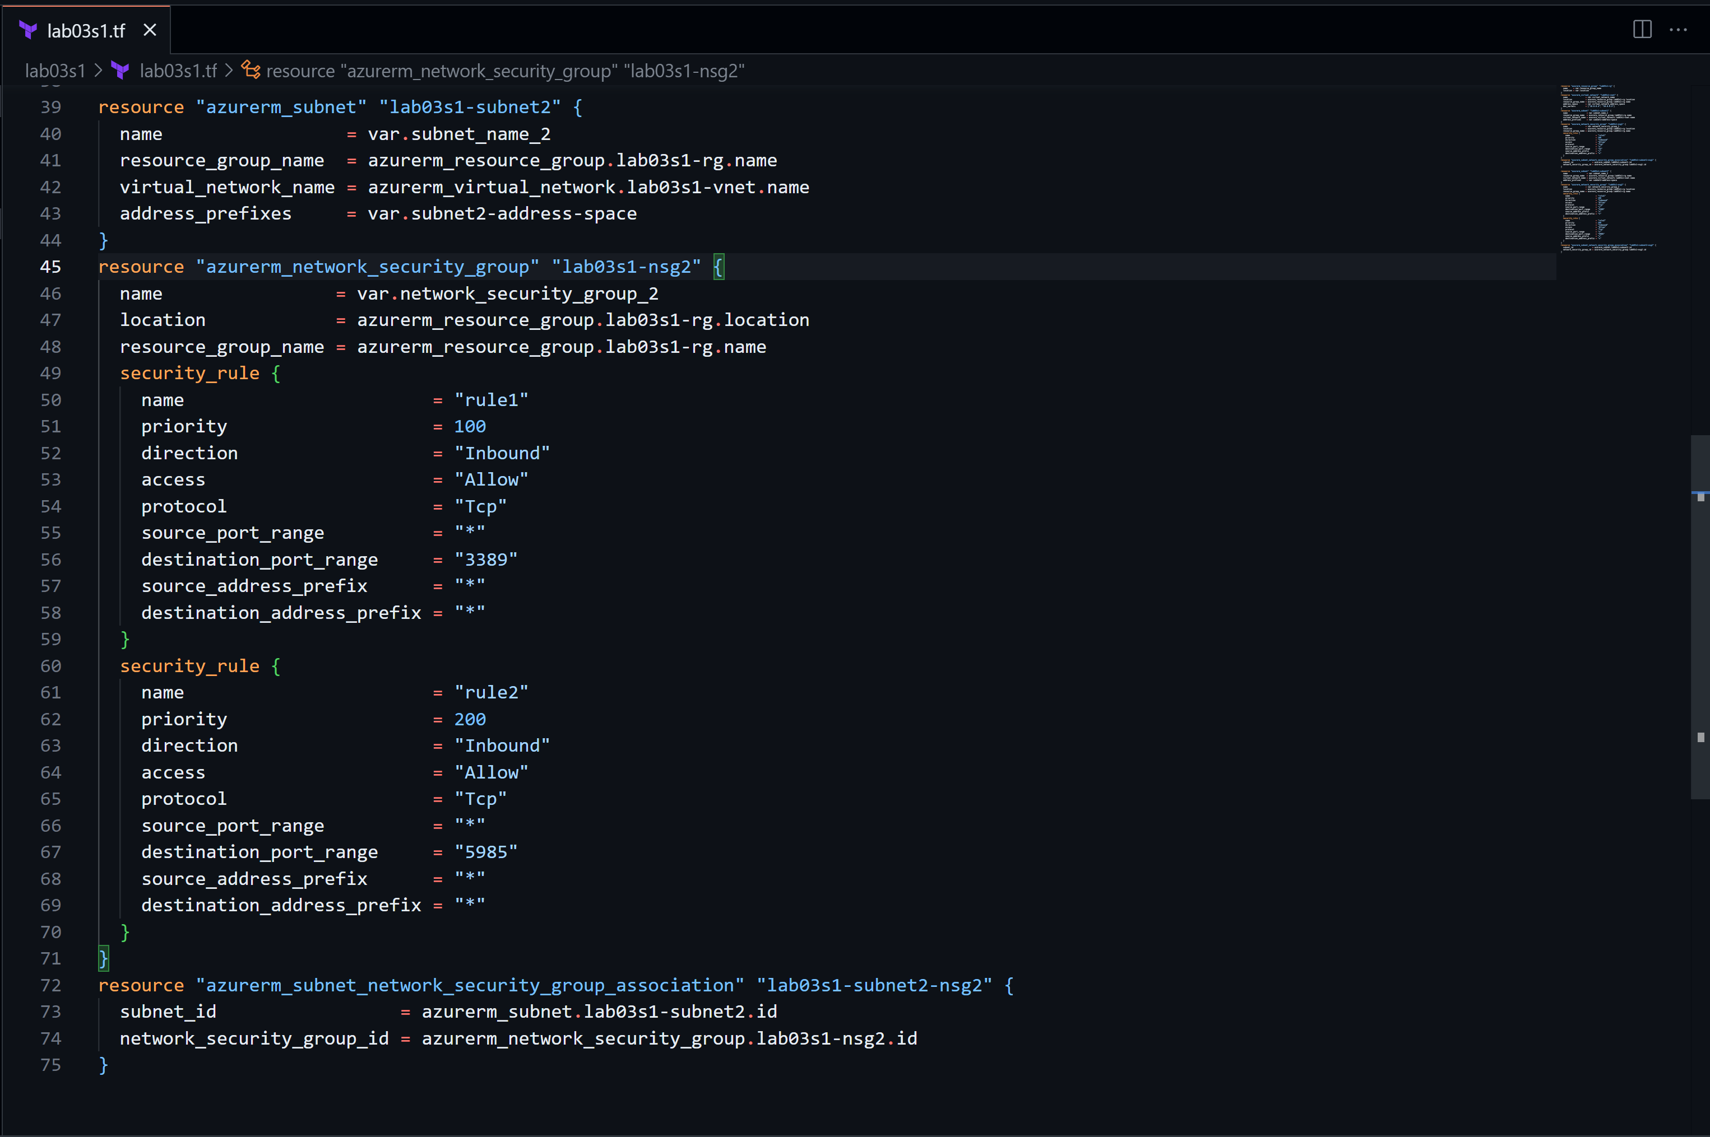
Part 4: Initialize Terraform
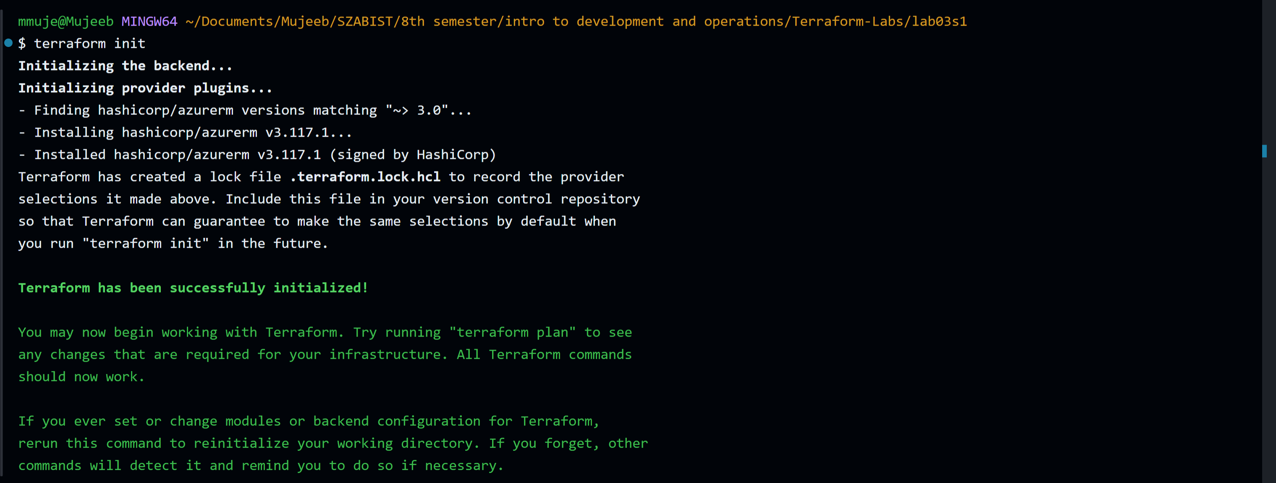
Part 5: Validate Configuration
Part 6: Run Simulation
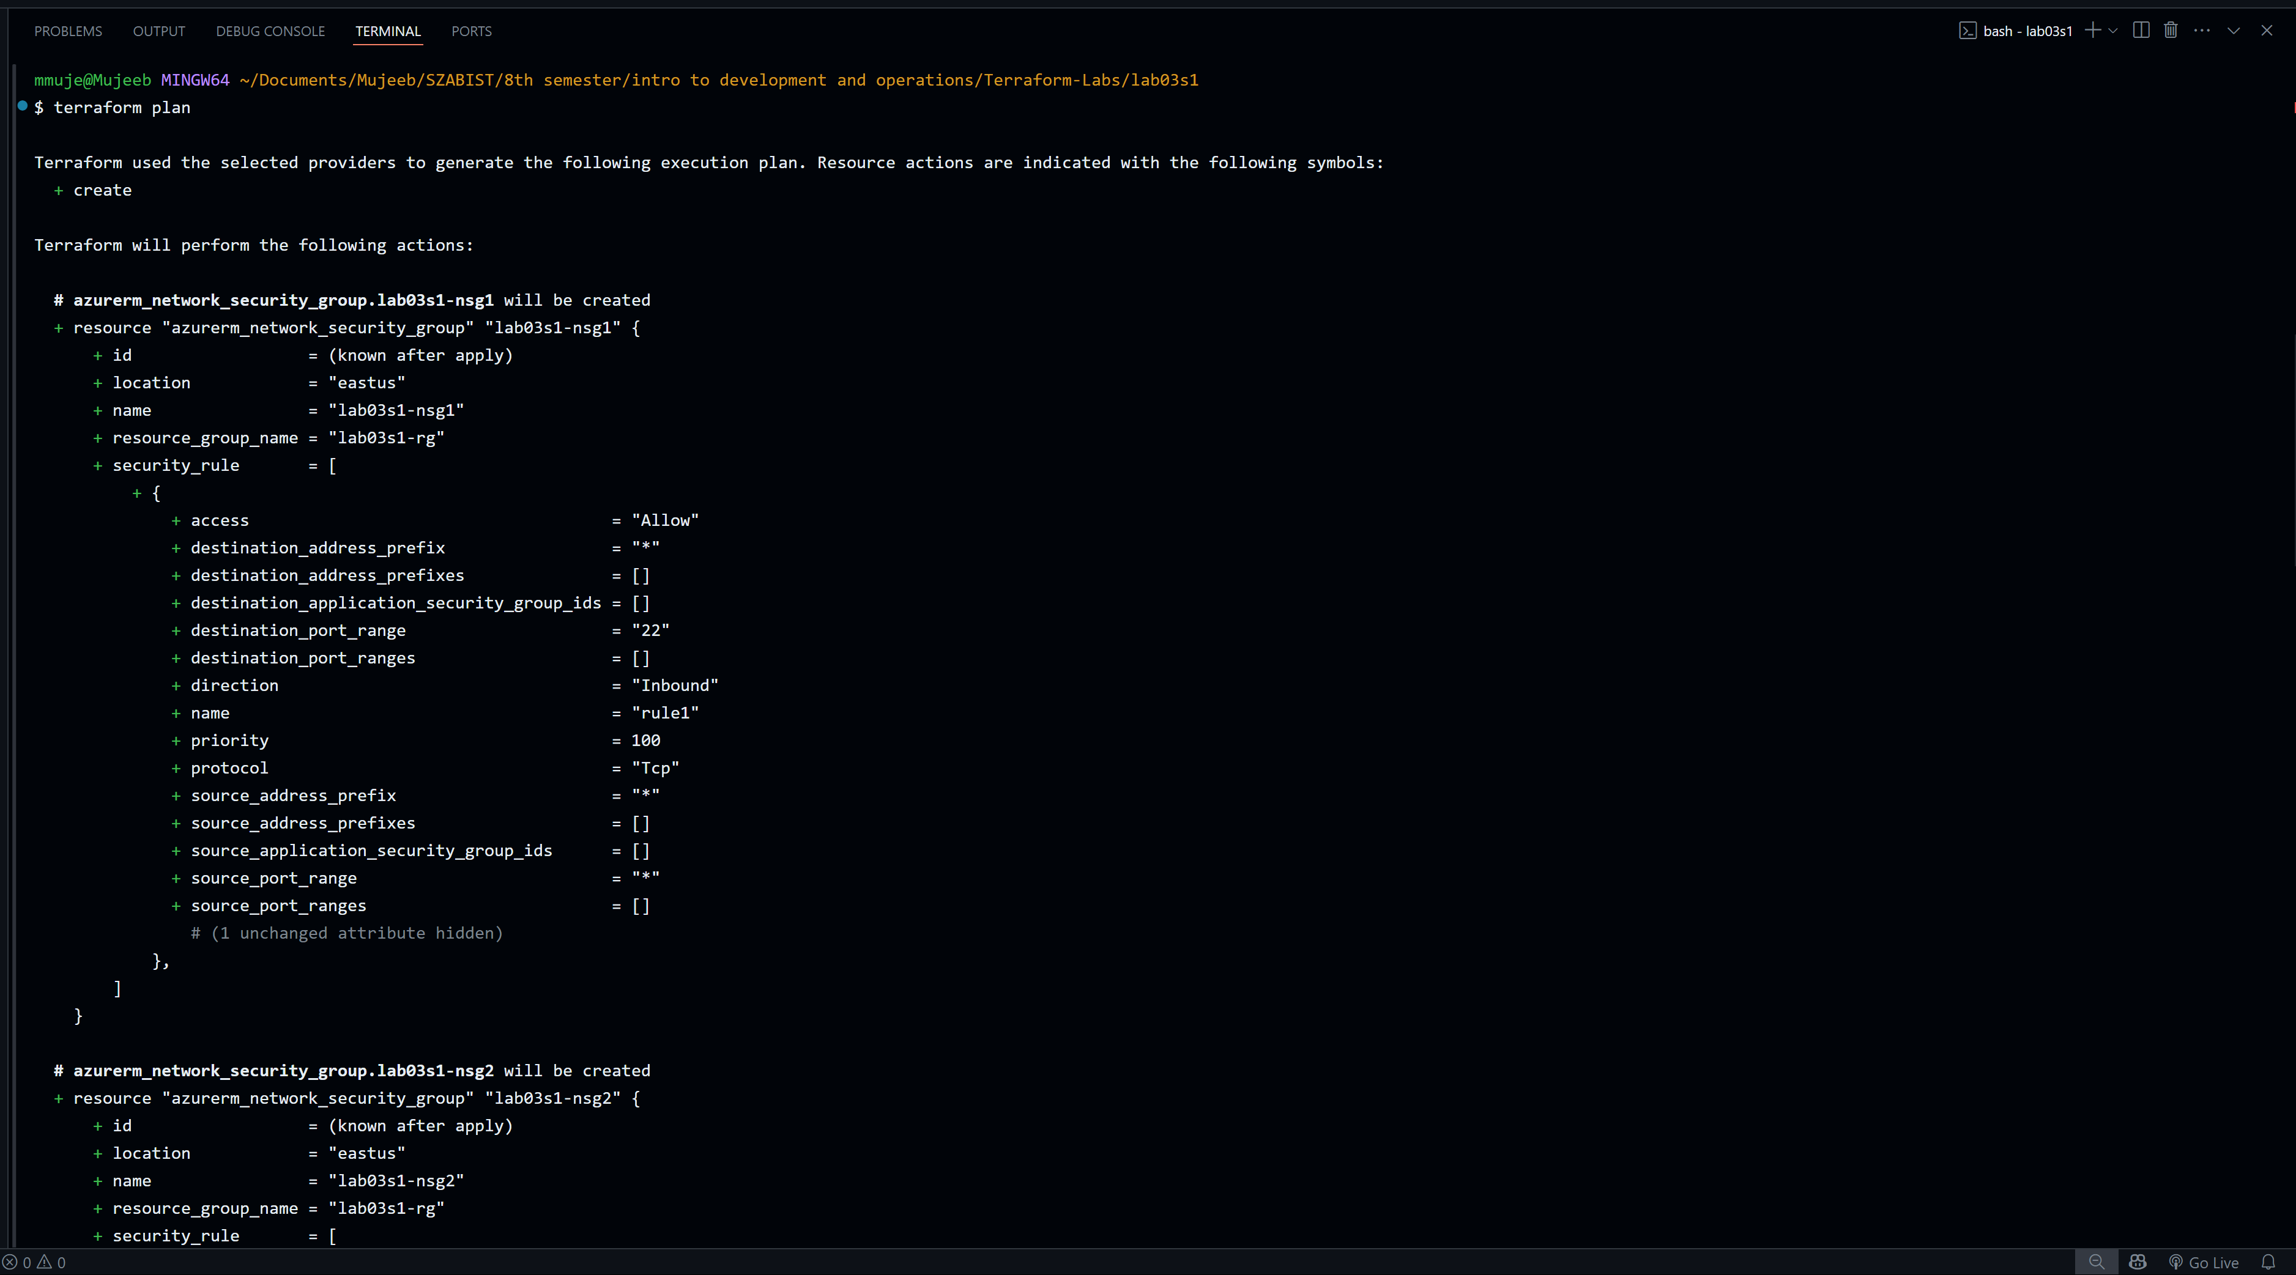
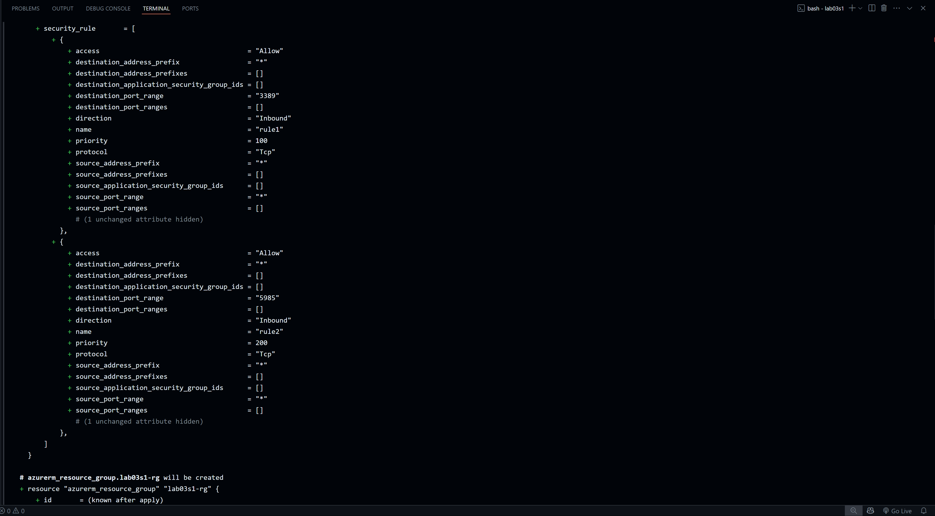
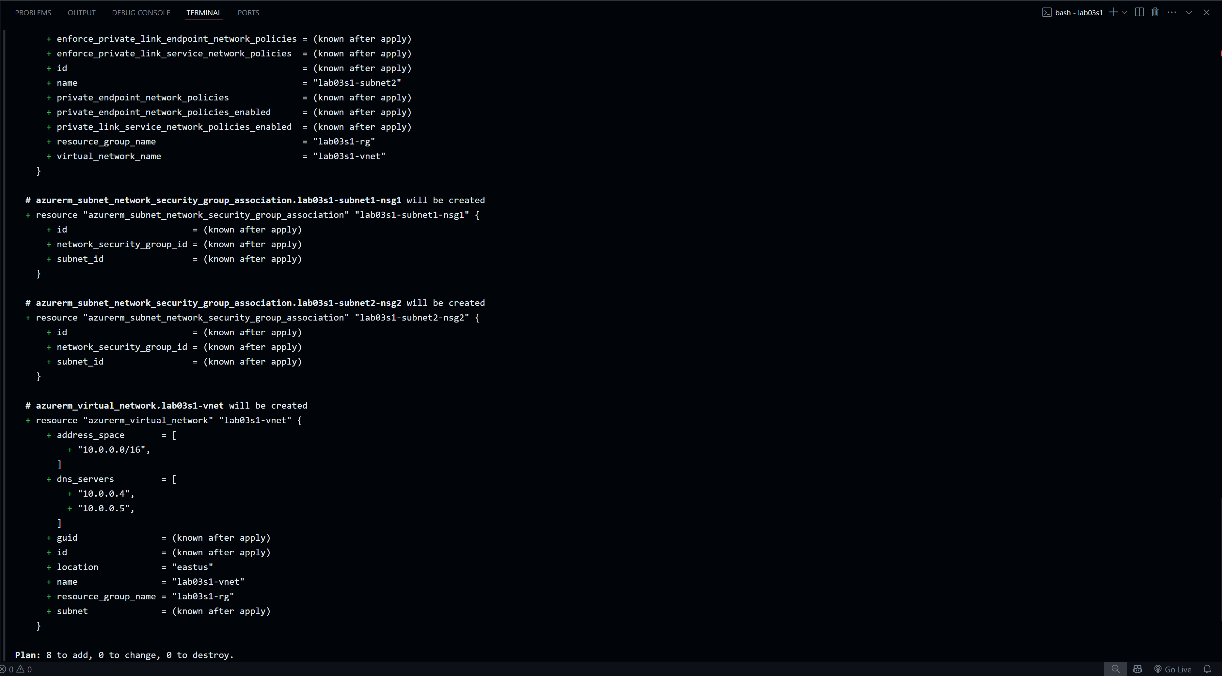

Part 7: Deploy Infrastructure
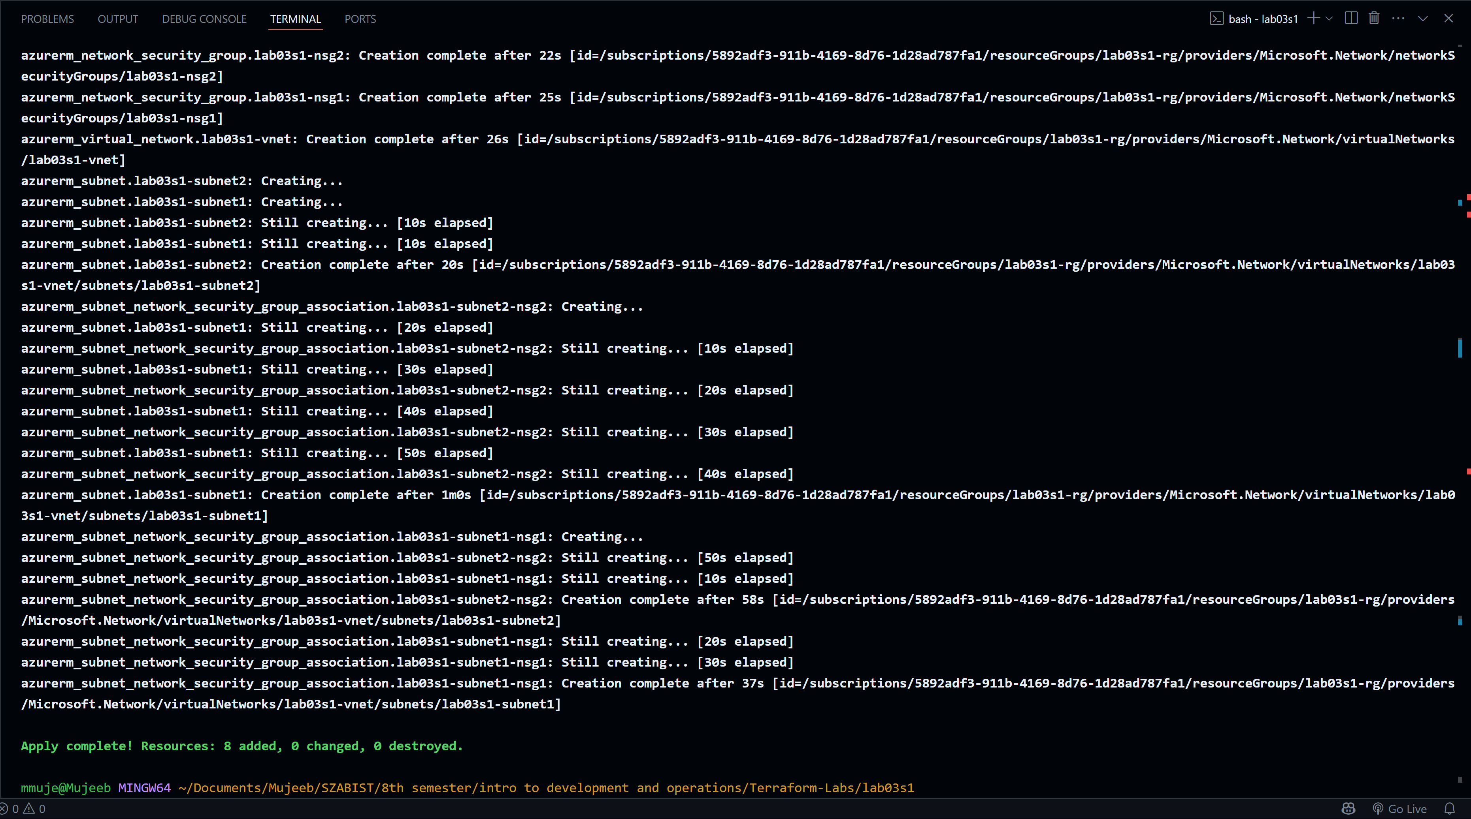
Part 8: Get Information from Terraform State
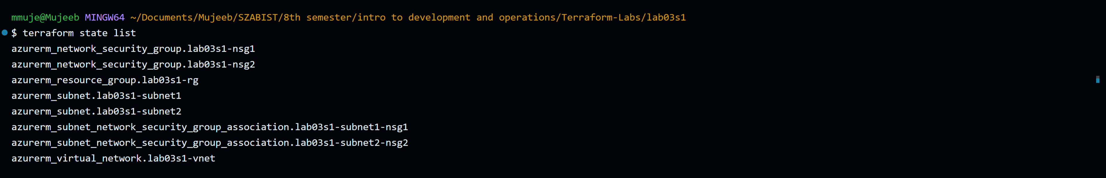
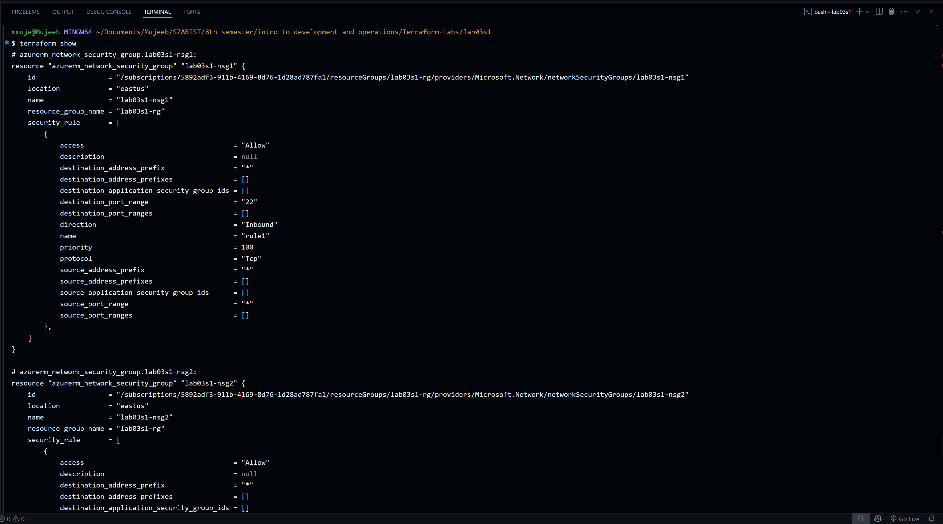
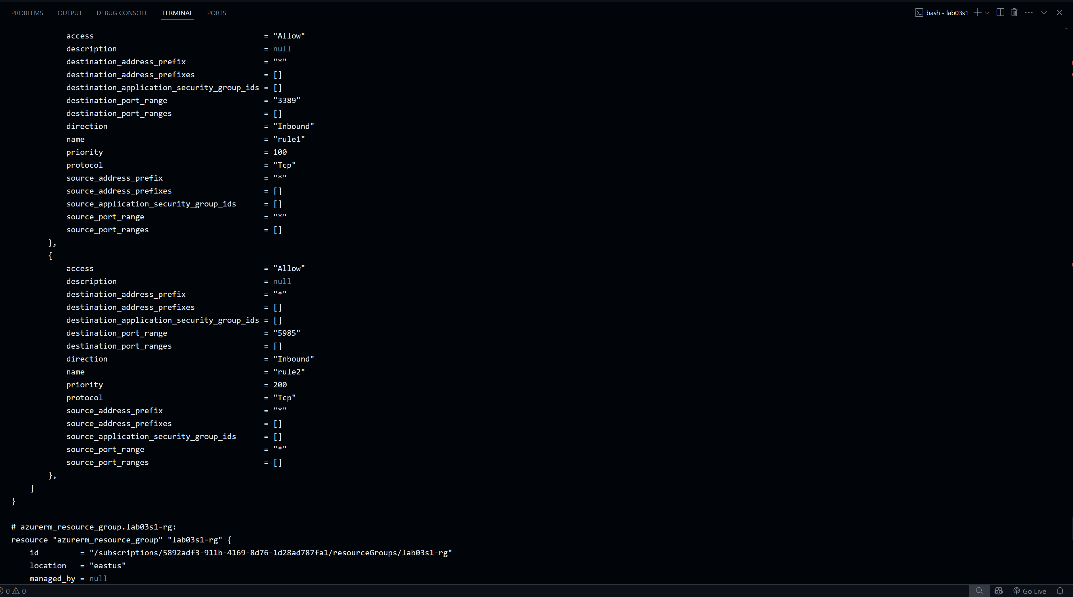
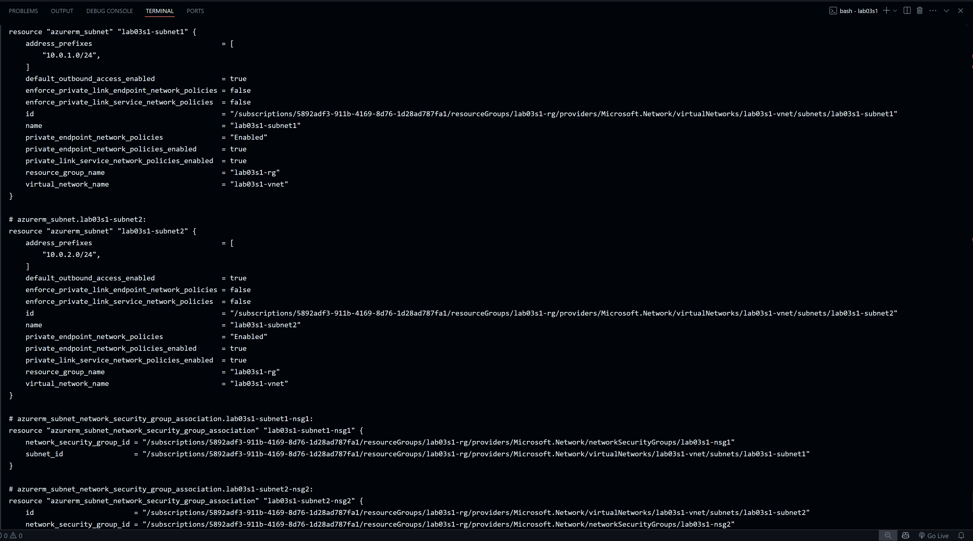
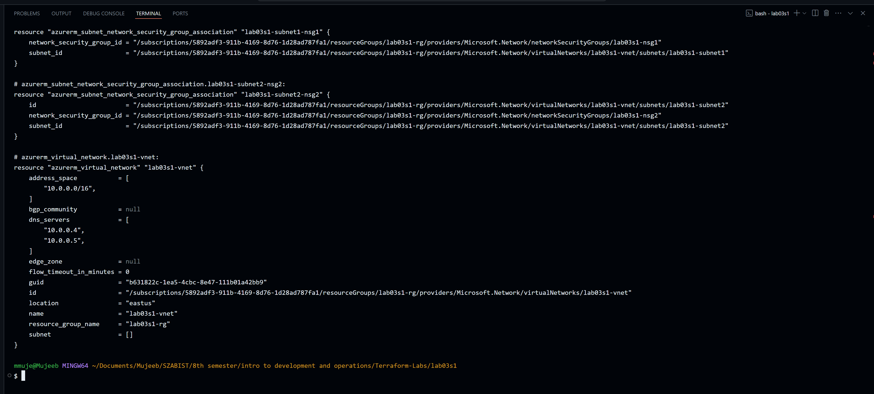
Part 9: Confirm Resource Creation in Azure
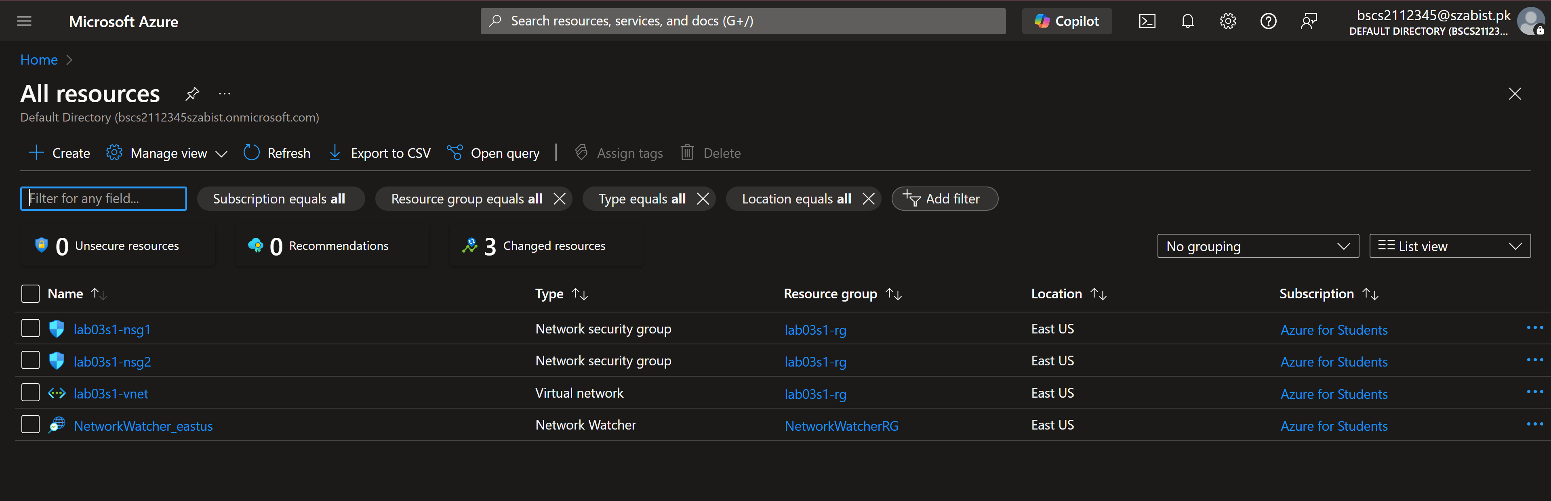
Part 10: Destroy All Resources and Verify
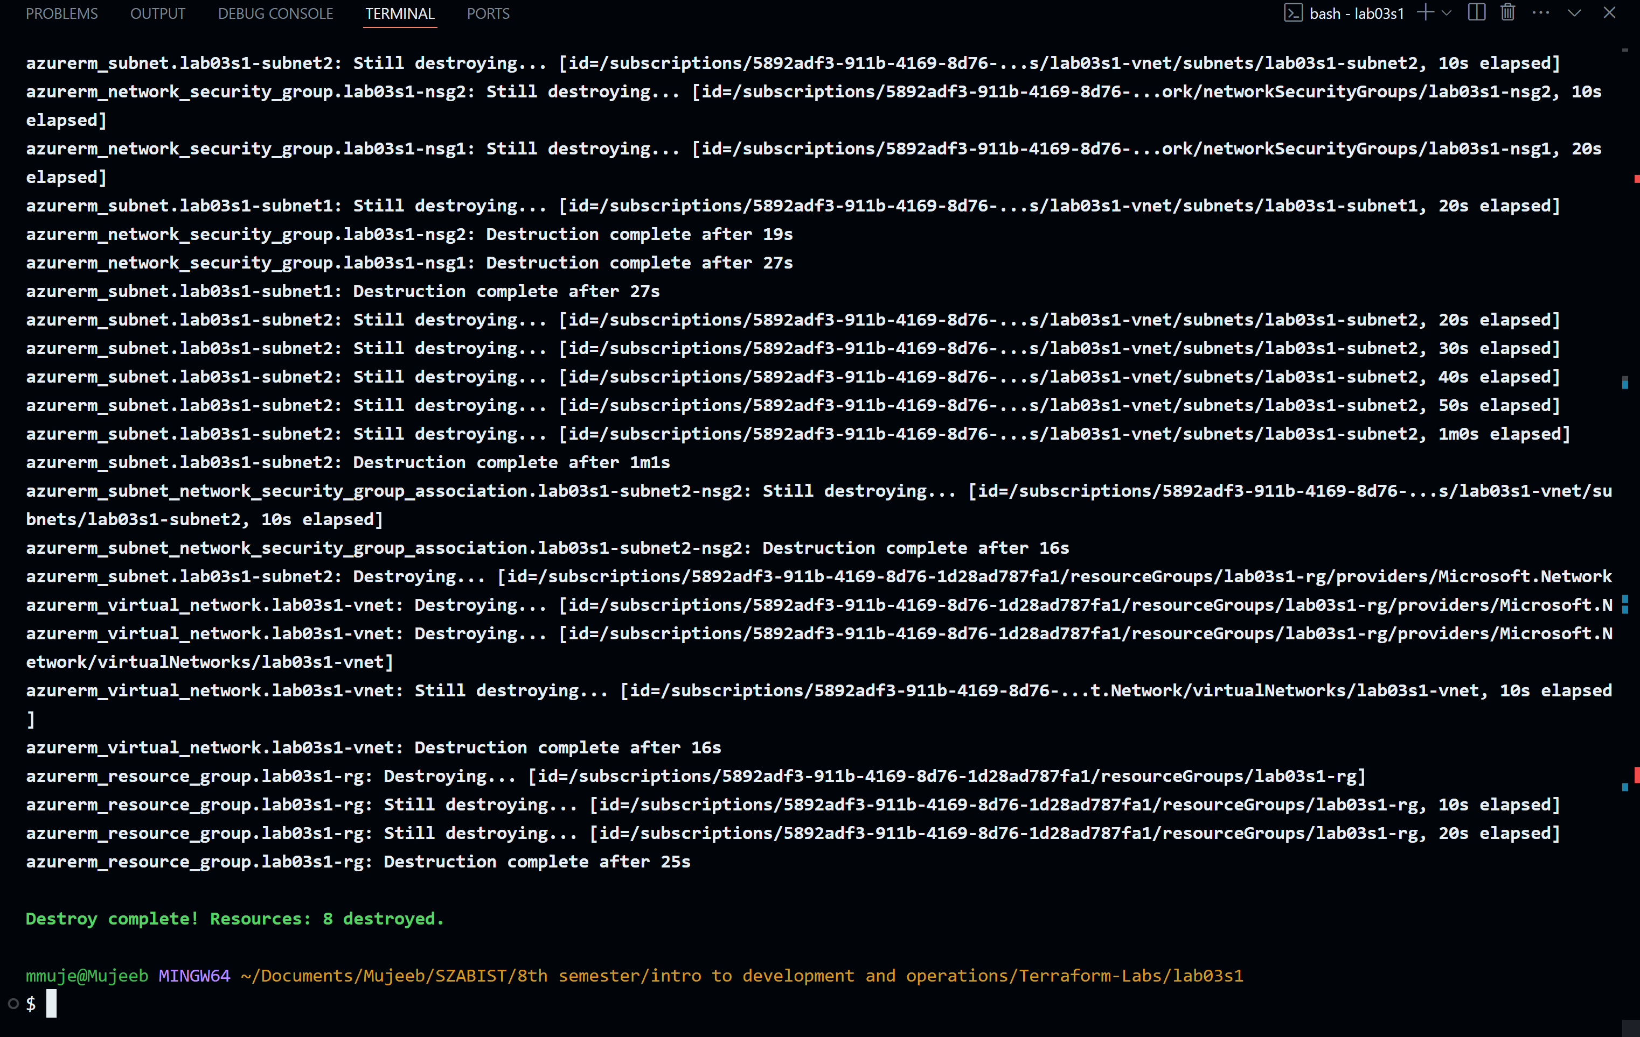

Section 2
Objectives:
- Use configuration from Section 1.
- Define resource and variable blocks for virtual machine resources.
- Validate, deploy, expand, analyze, and destroy infrastructure.
Part 1: Prepare for the Lab
Part 2: Update vars03s2.tf File
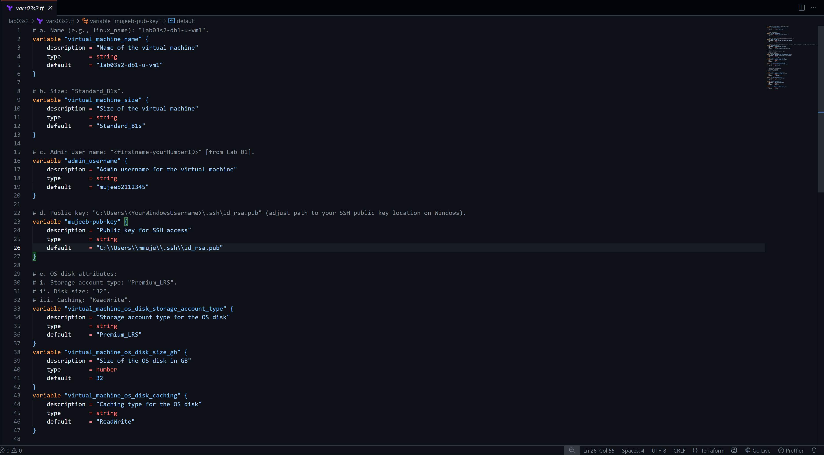
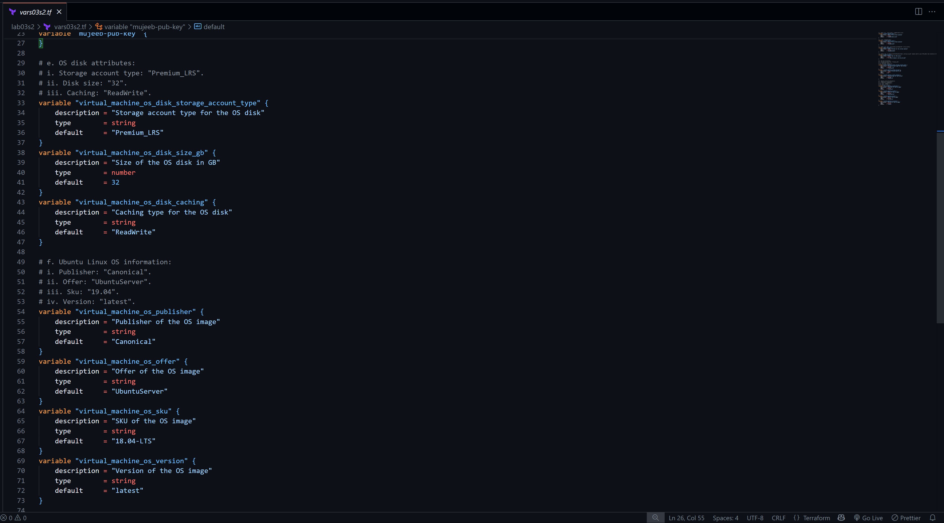

Part 3: Update lab03s2.tf File
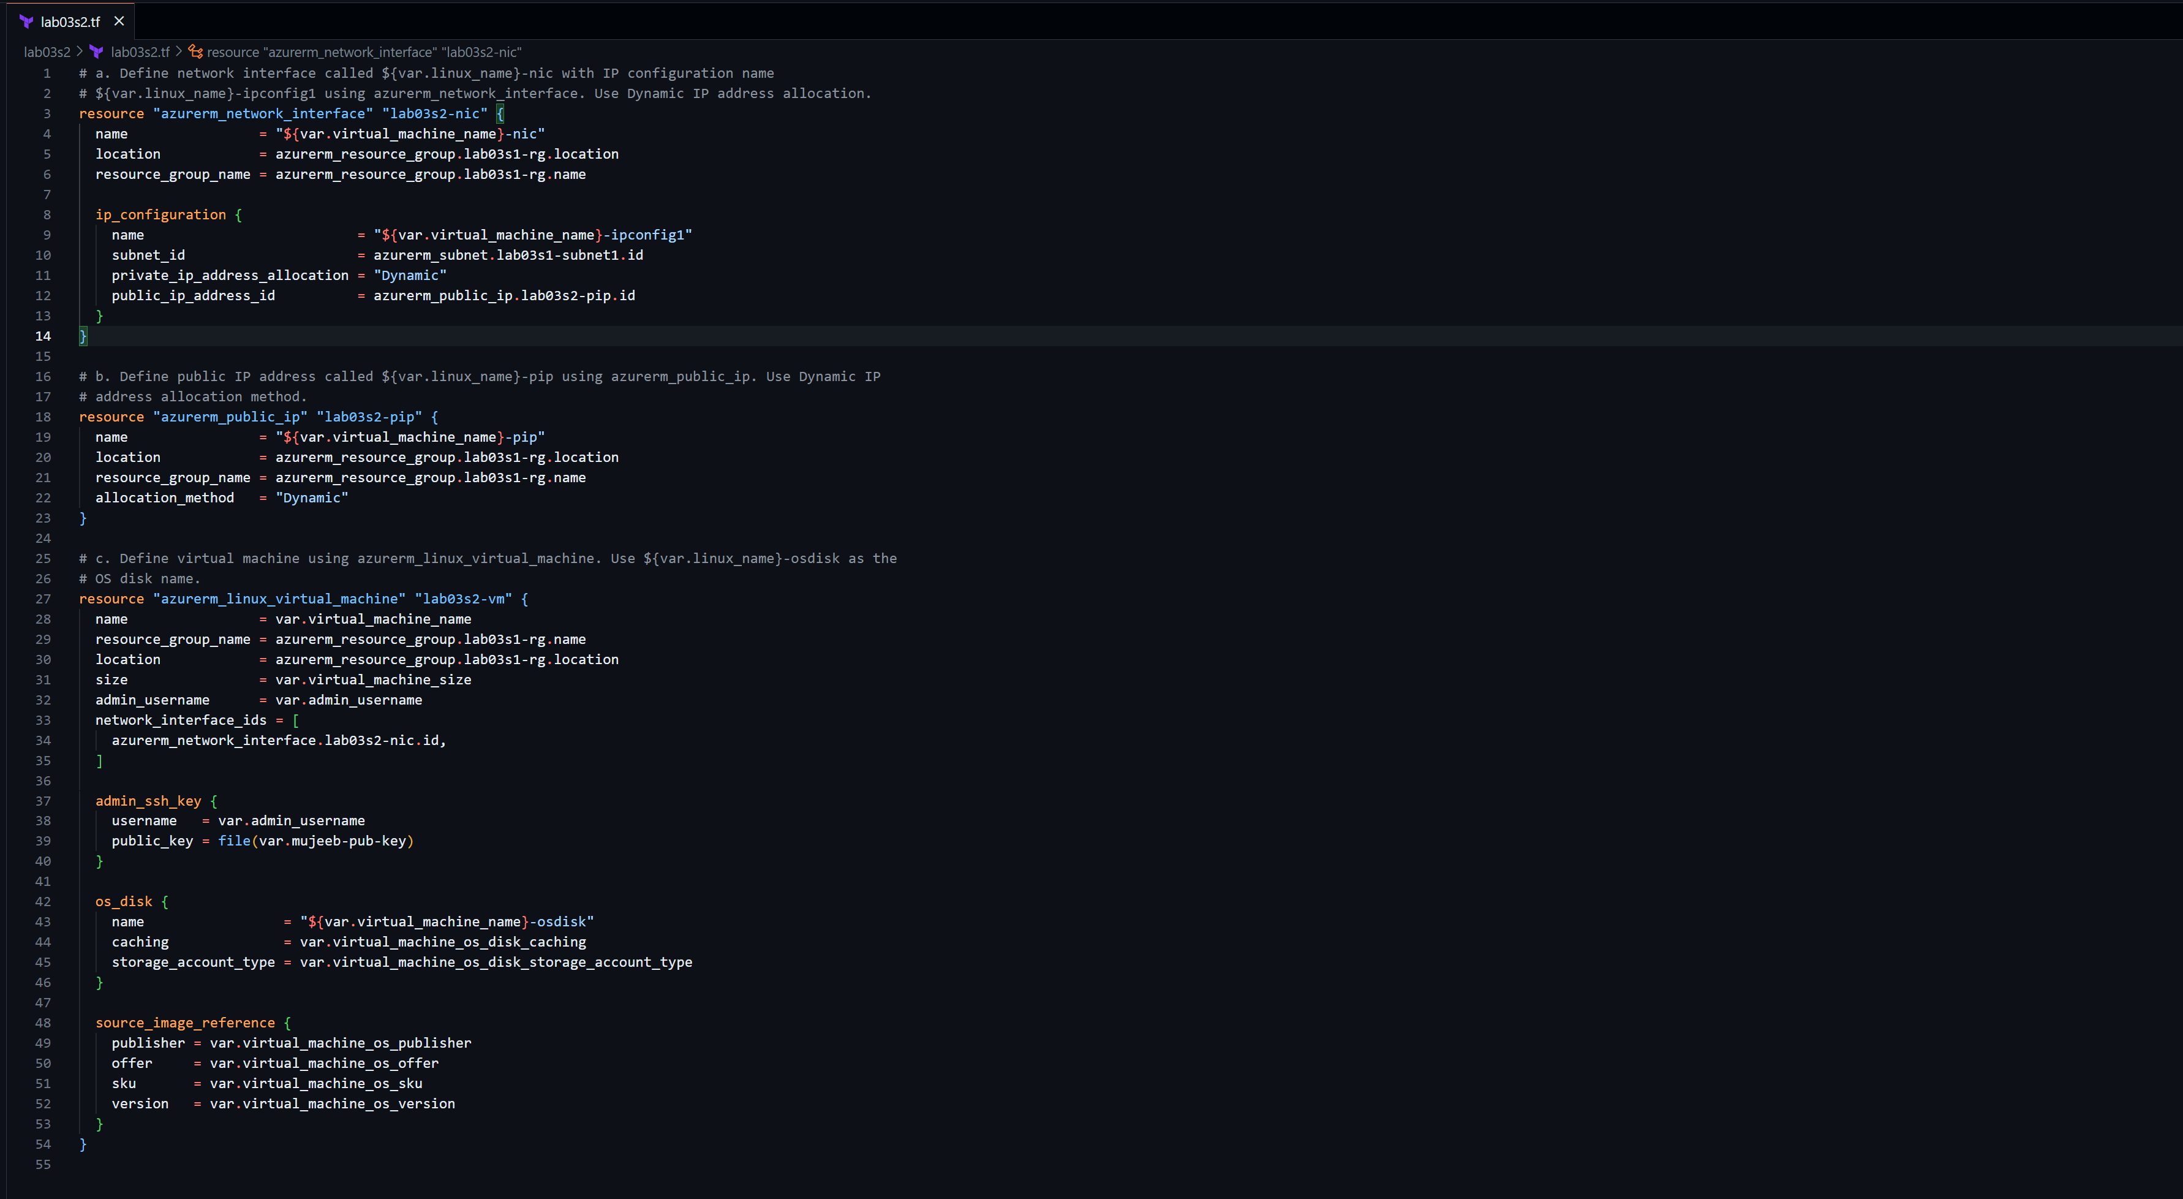
Part 4: Initialize Terraform
Part 5: Validate Configuration
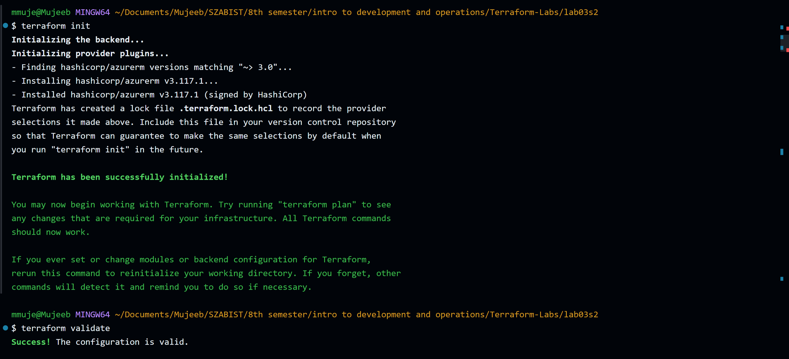

Part 6: Run Simulation
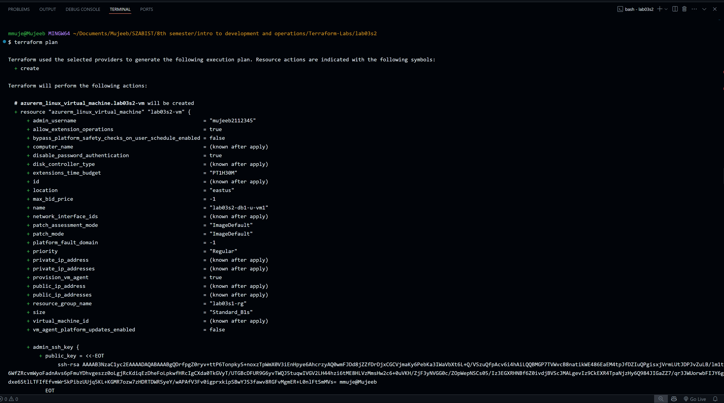
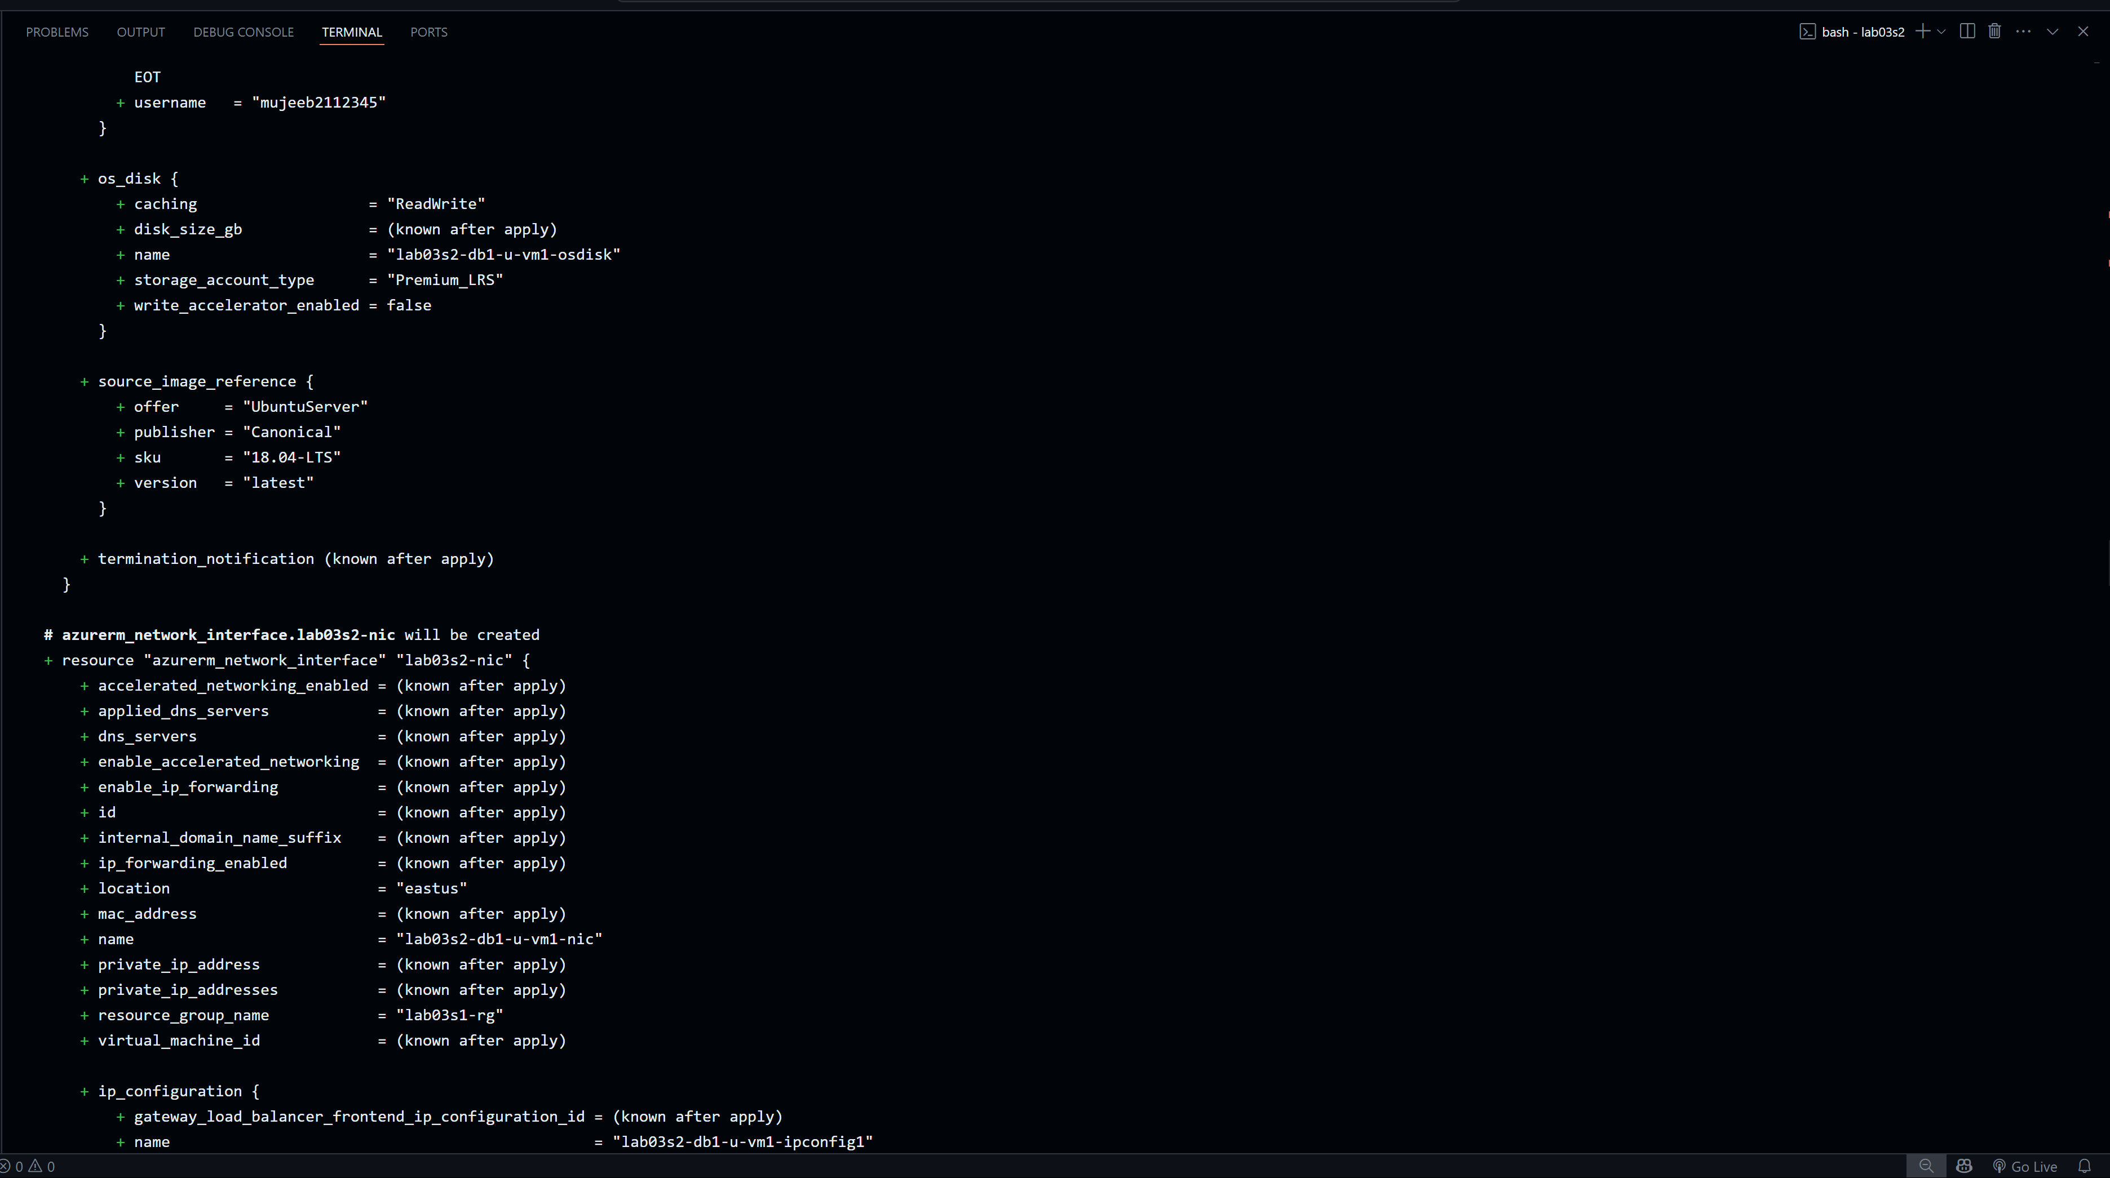
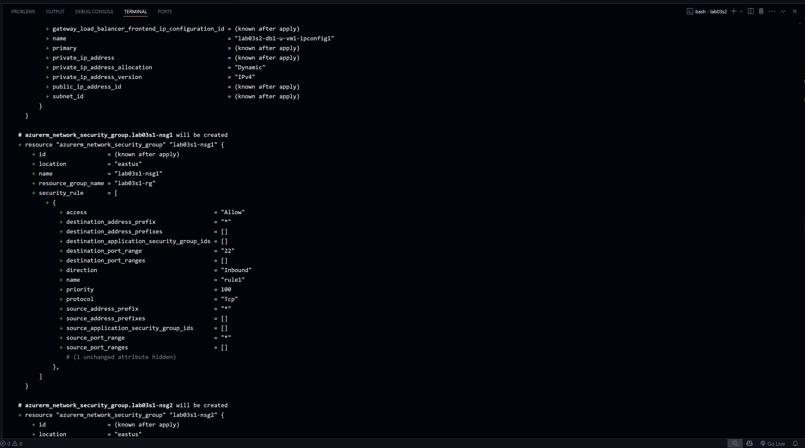
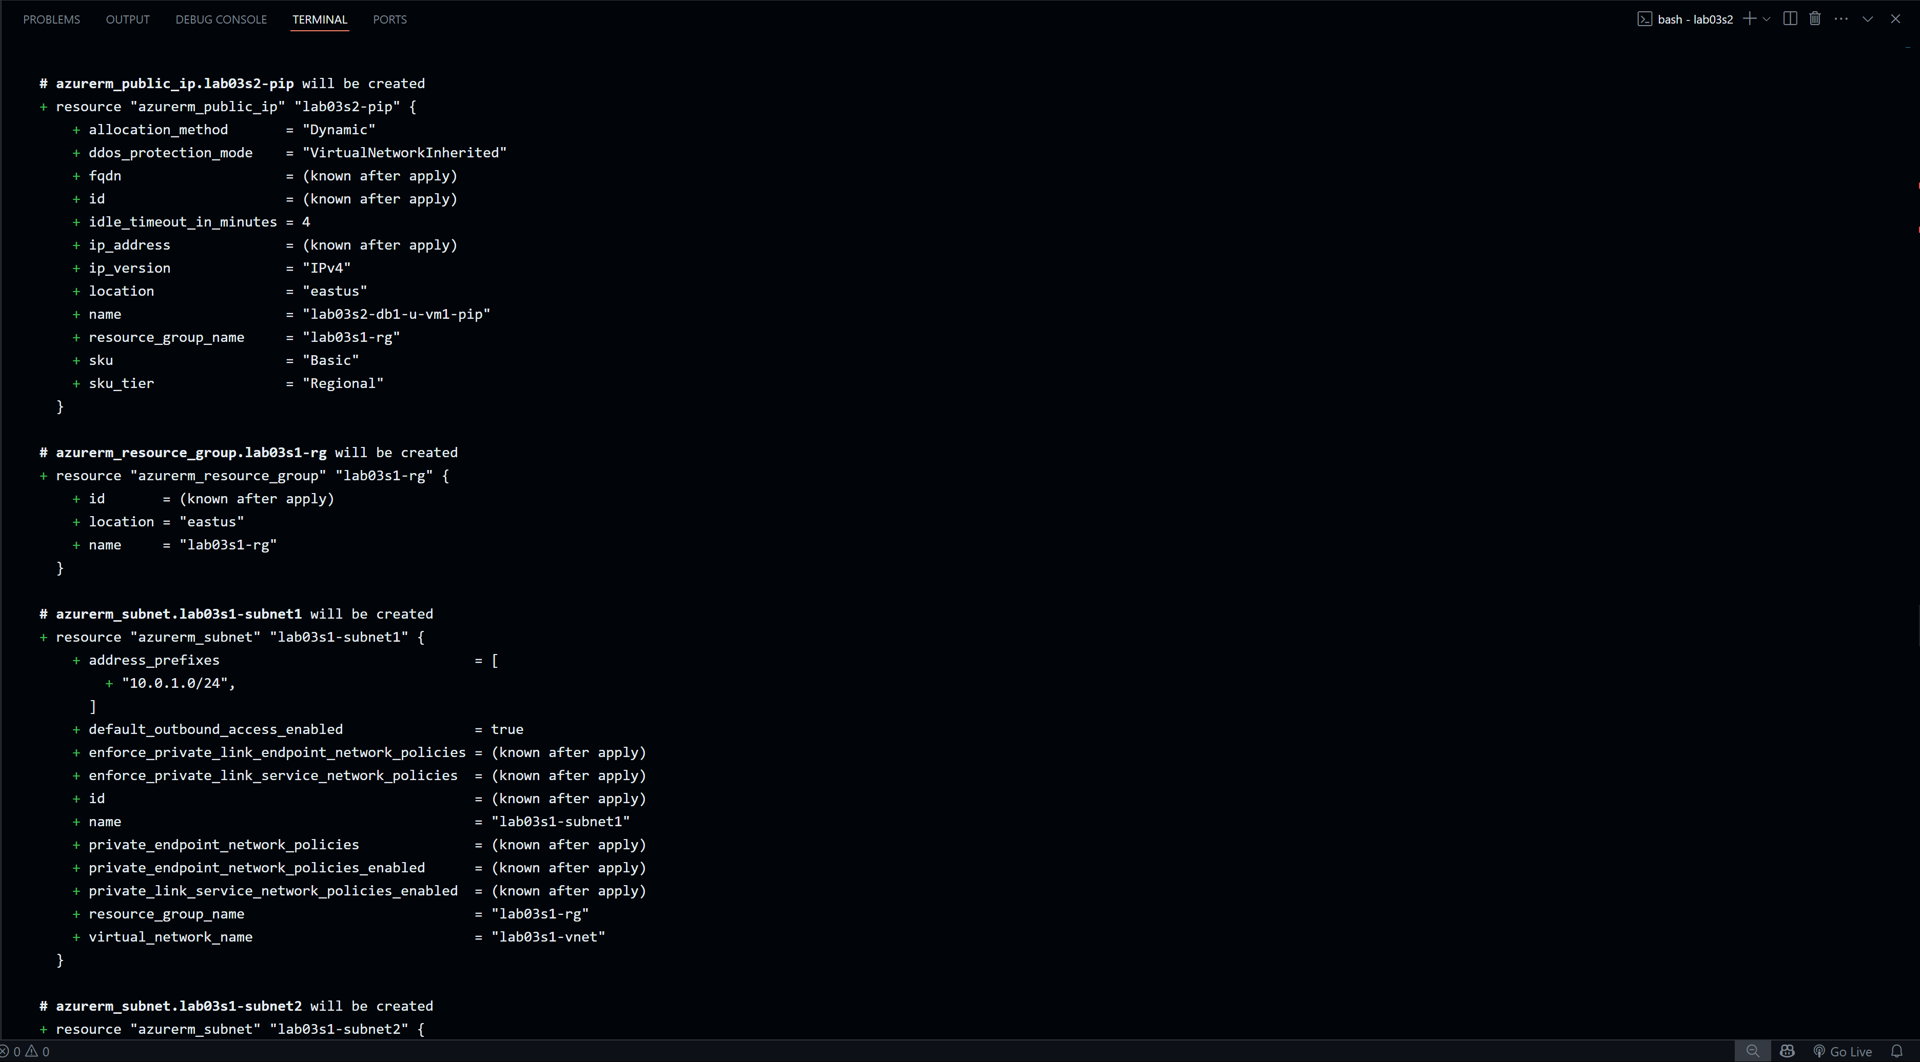
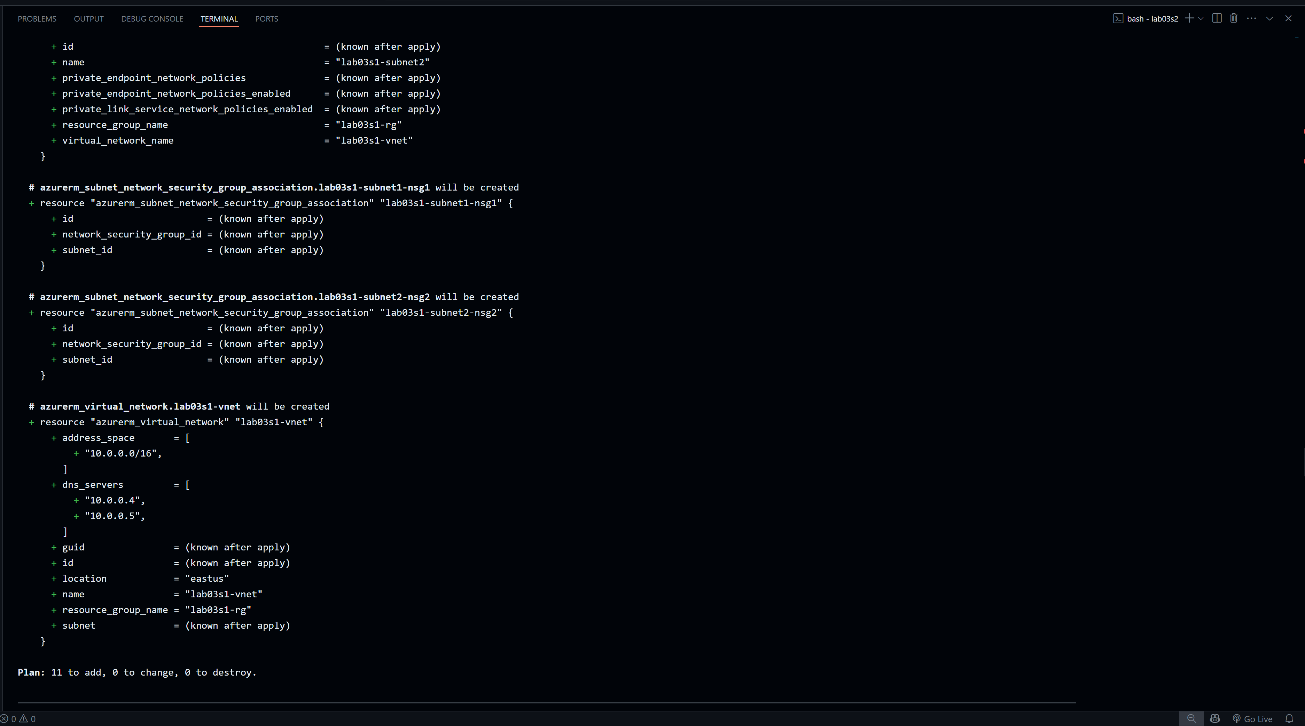
Part 7: Deploy Infrastructure
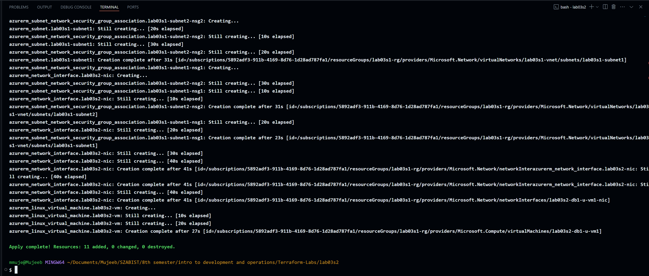

Part 8: Get Information from Terraform State
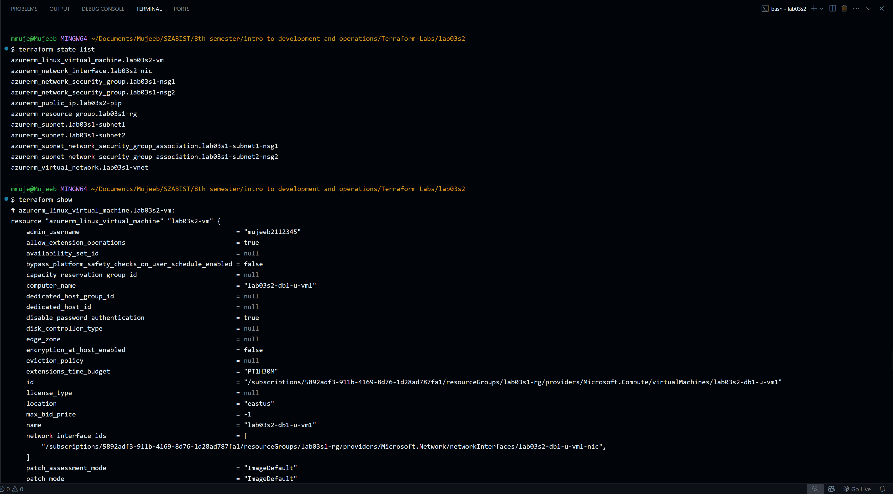
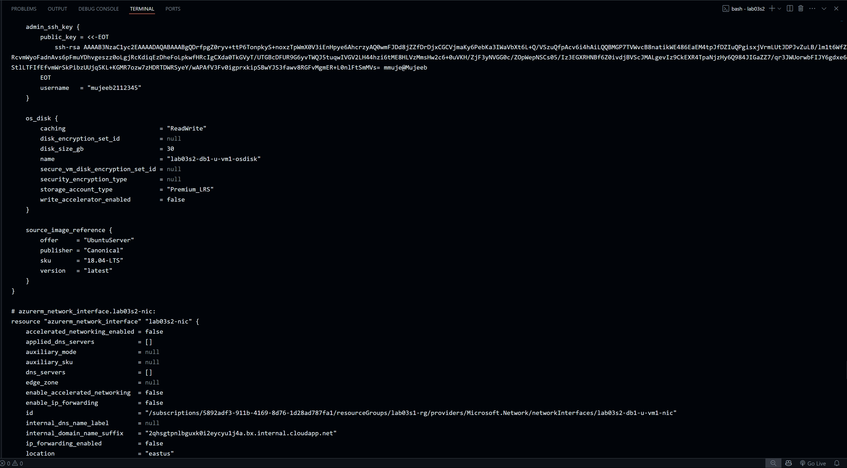
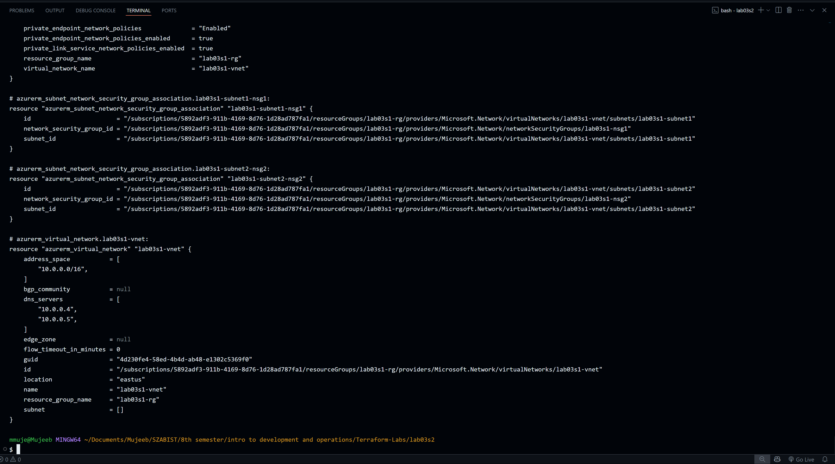
Part 9: Confirm Resource Creation in Azure
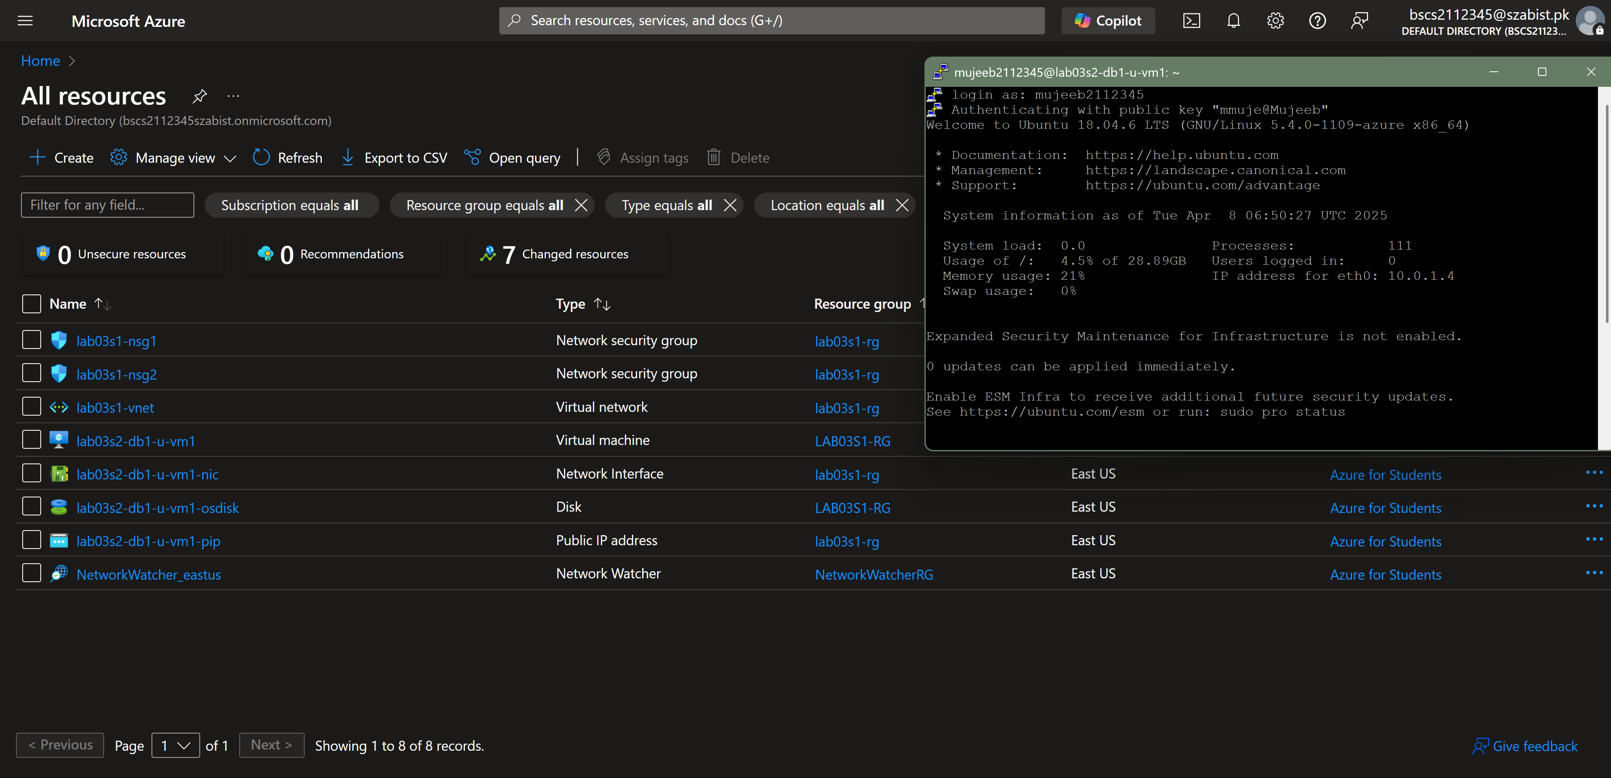

Part 10: Destroy All Resources and Verify
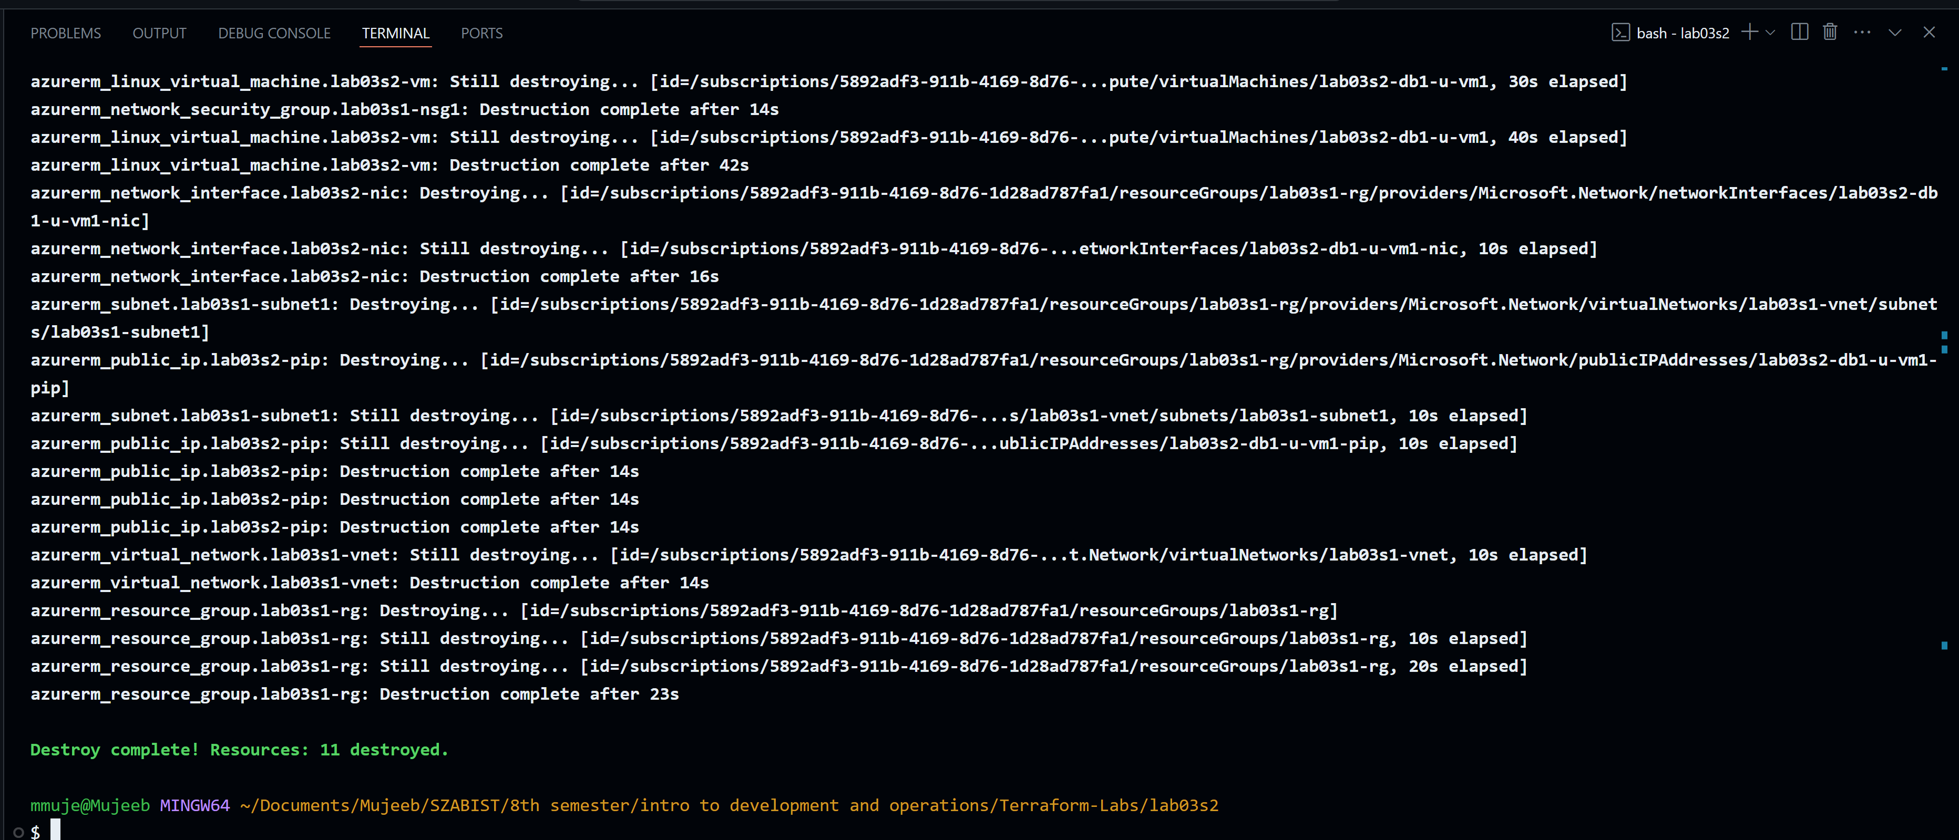
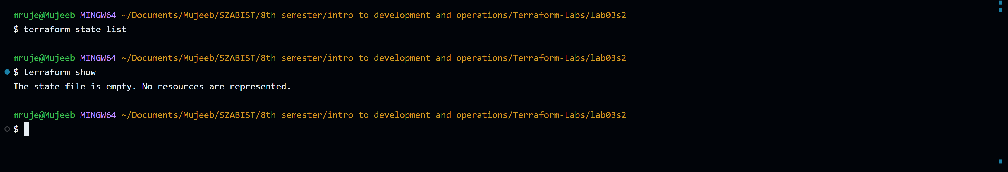

Section 3
Objectives:
- Use configuration from Section 2.
- Define a locals block to assign tags to resources.
- Validate, deploy, expand, analyze, and destroy infrastructure.
Part 1: Prepare for the Lab
Part 2: Update vars03s3.tf File
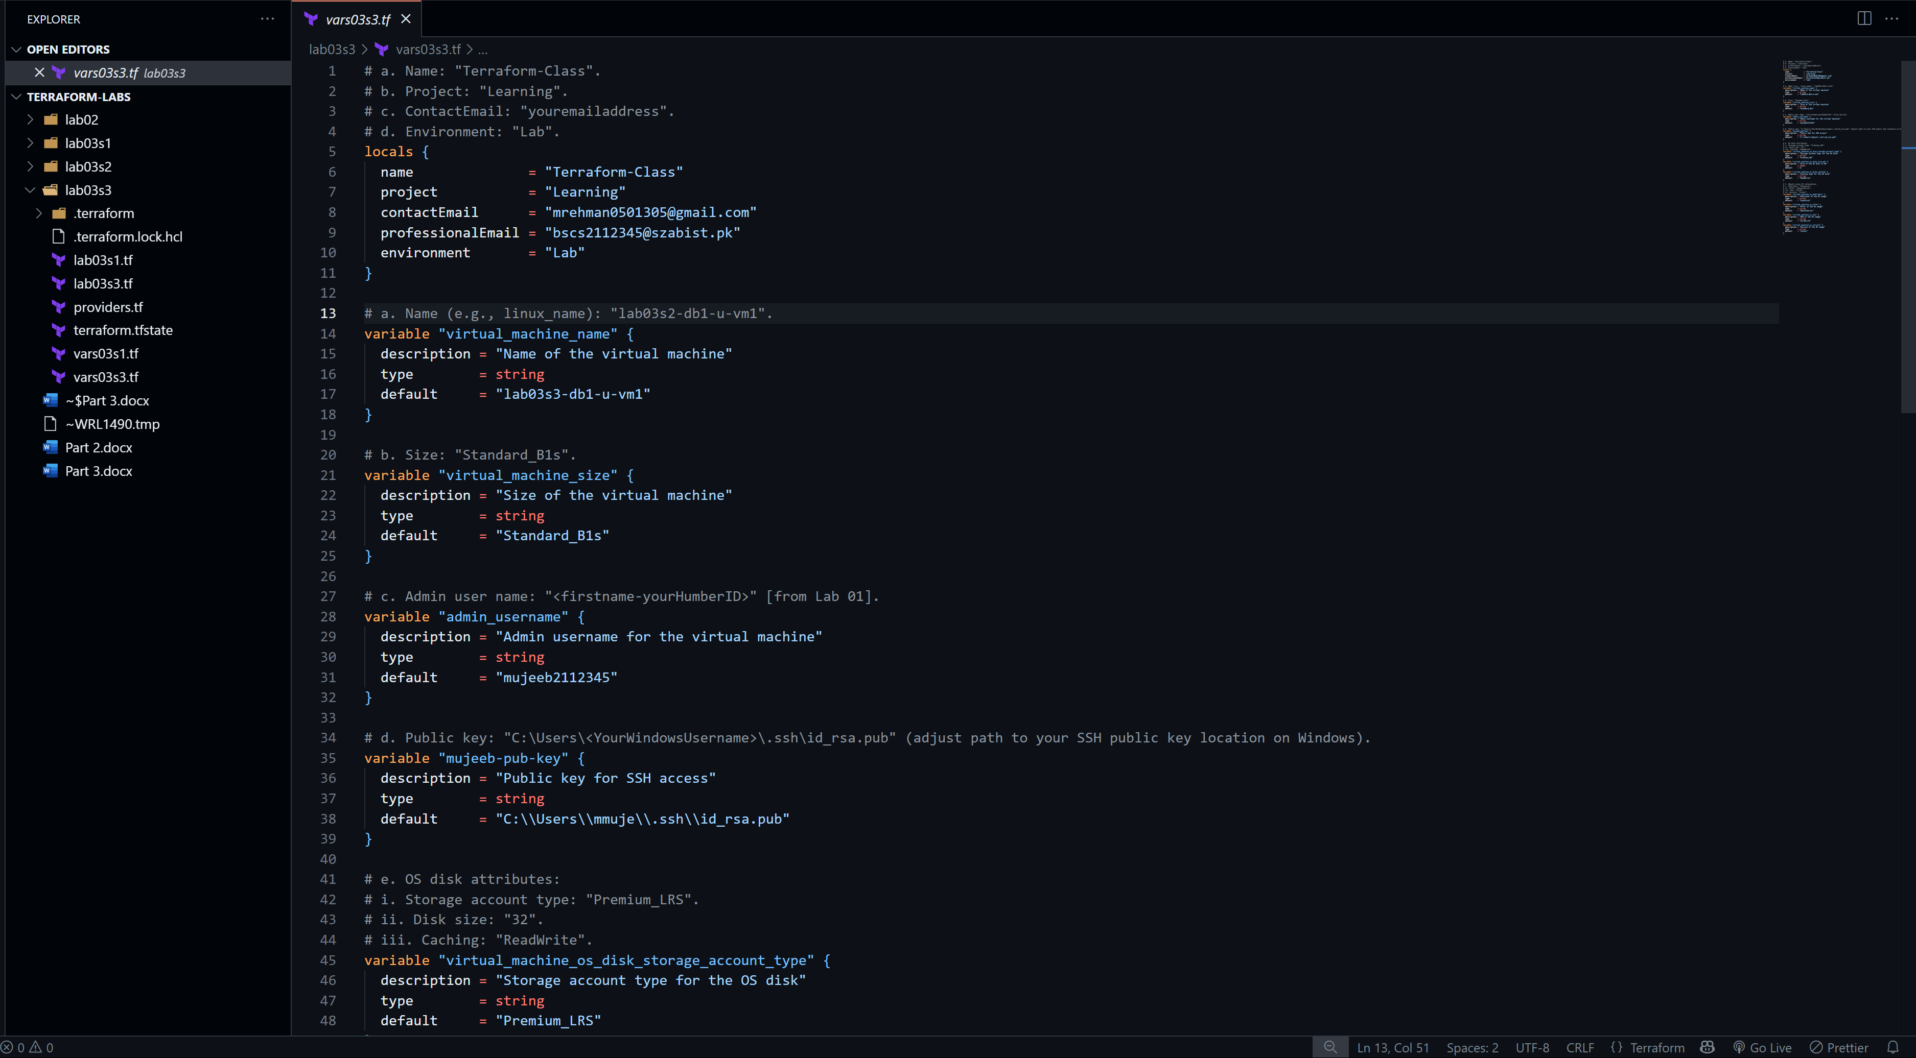
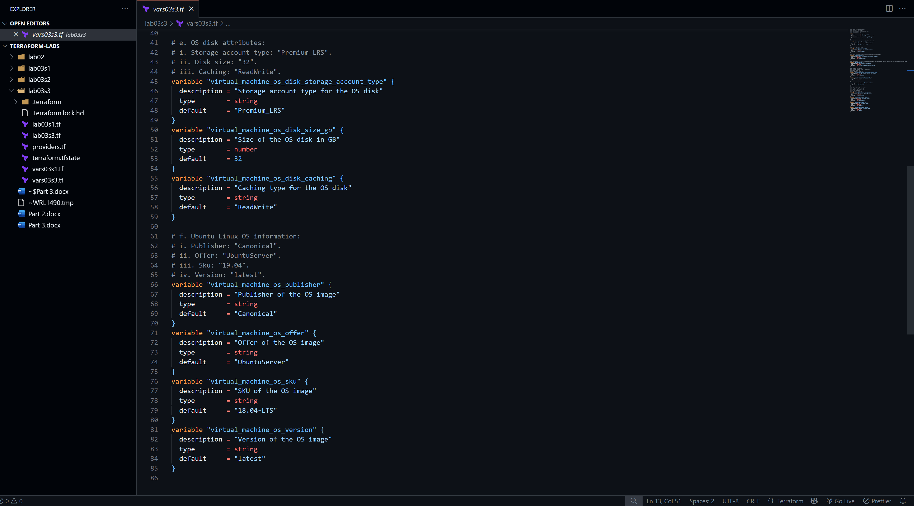
Part 3: Update lab03s3.tf File
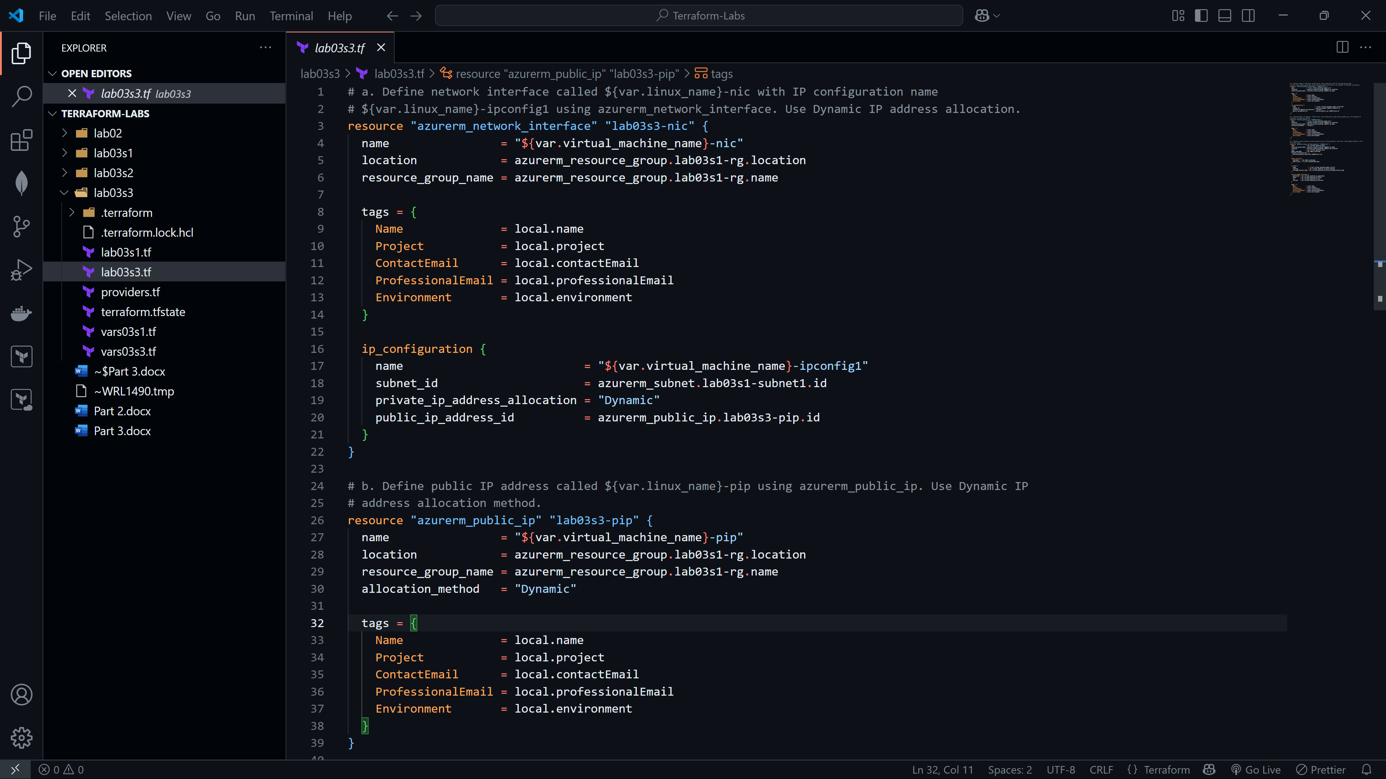
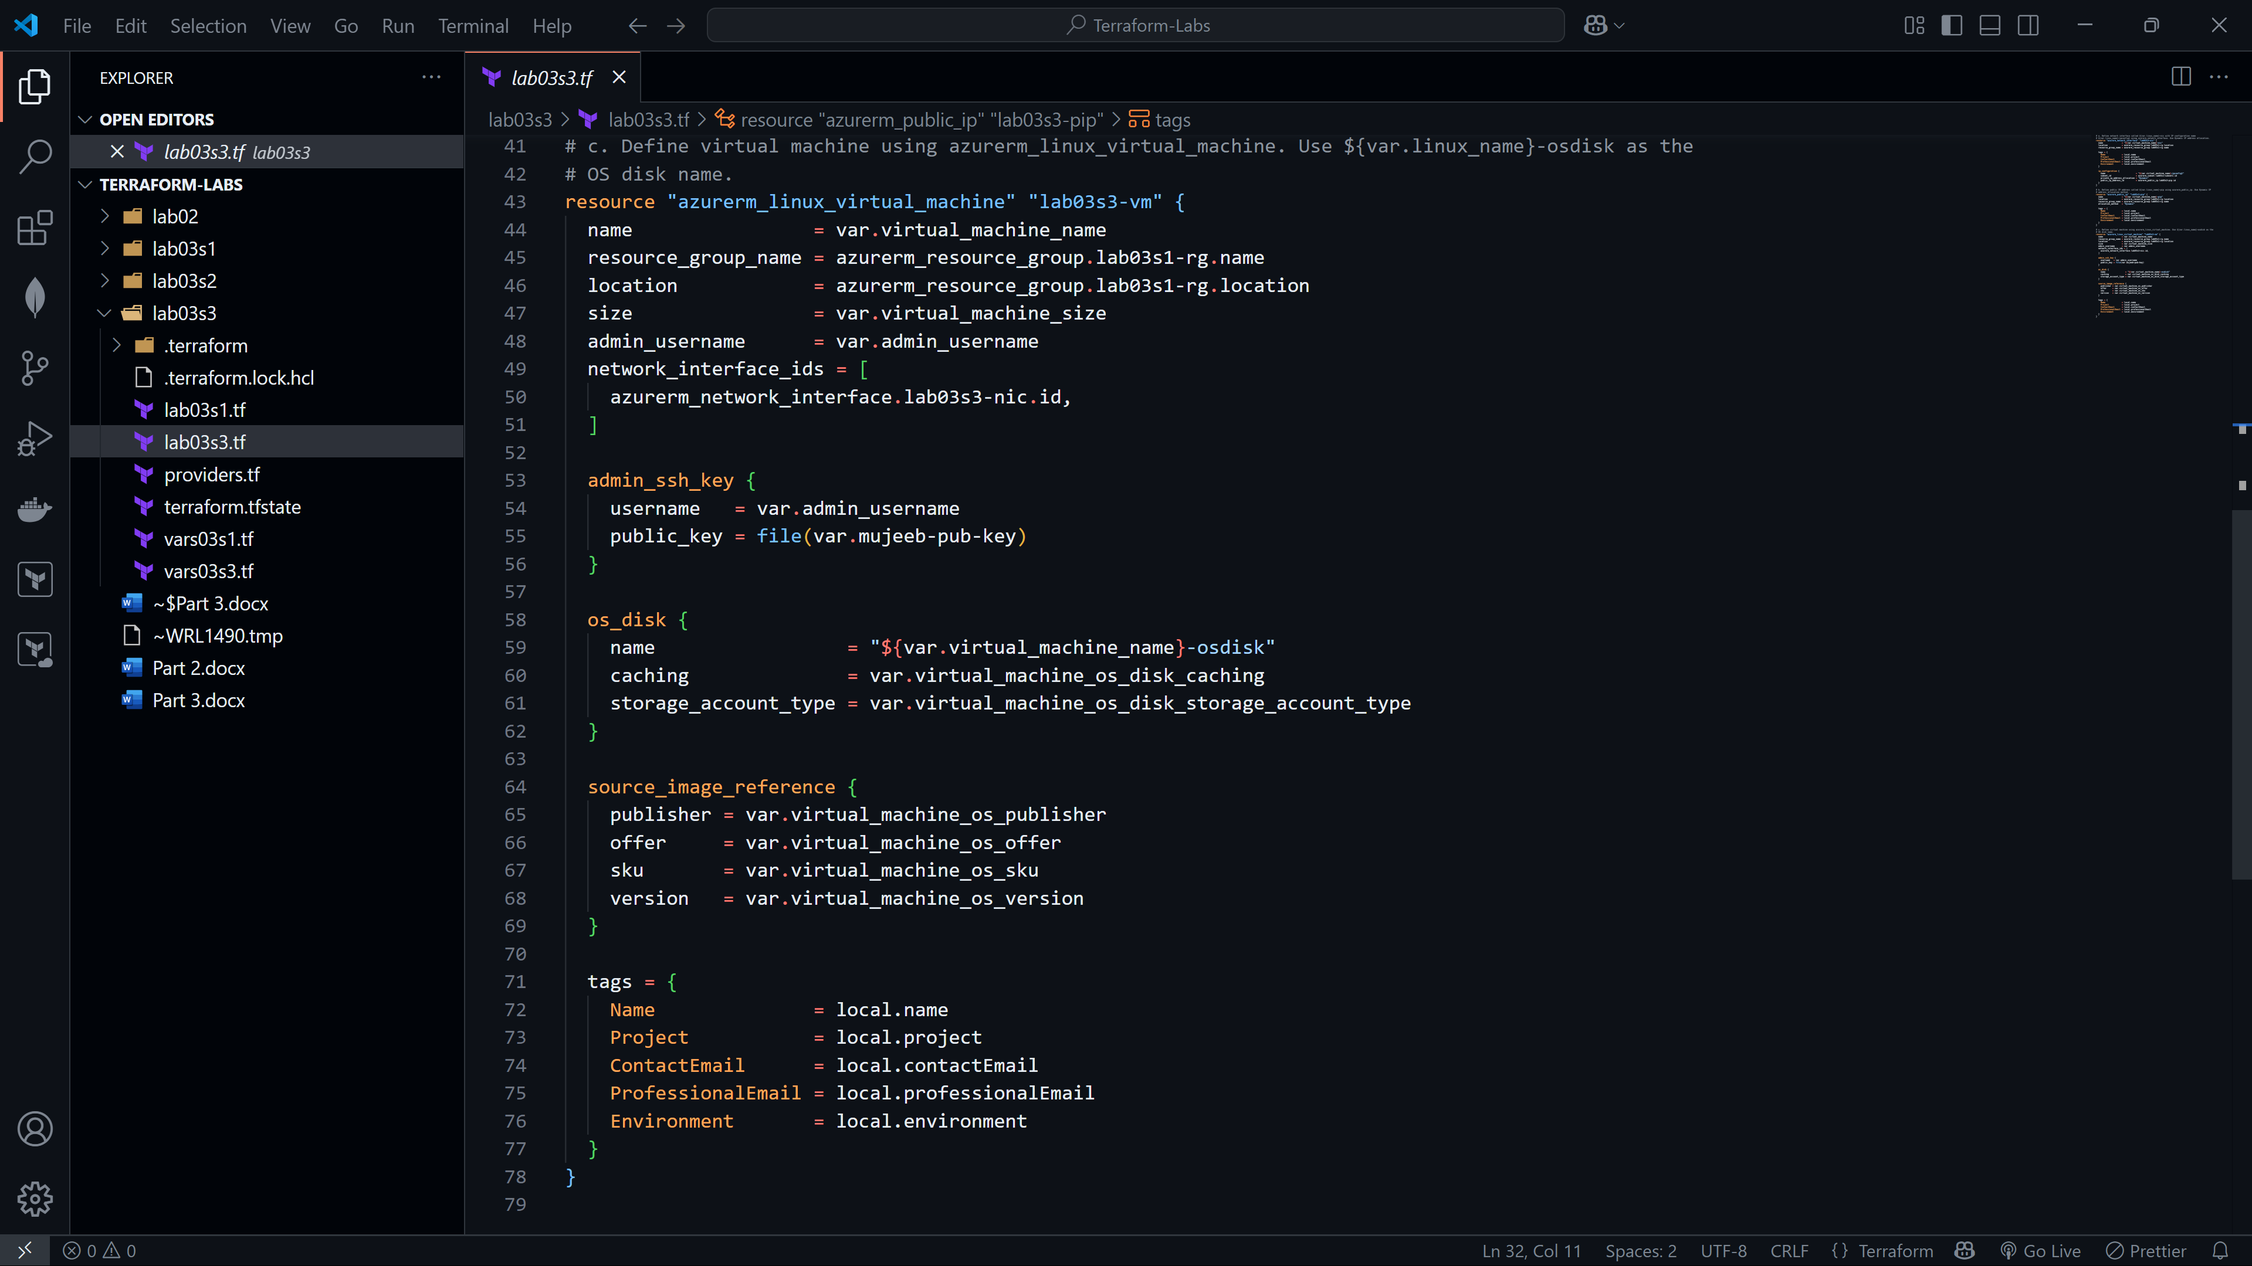

Part 4: Initialize Terraform
Part 5: Validate Configuration
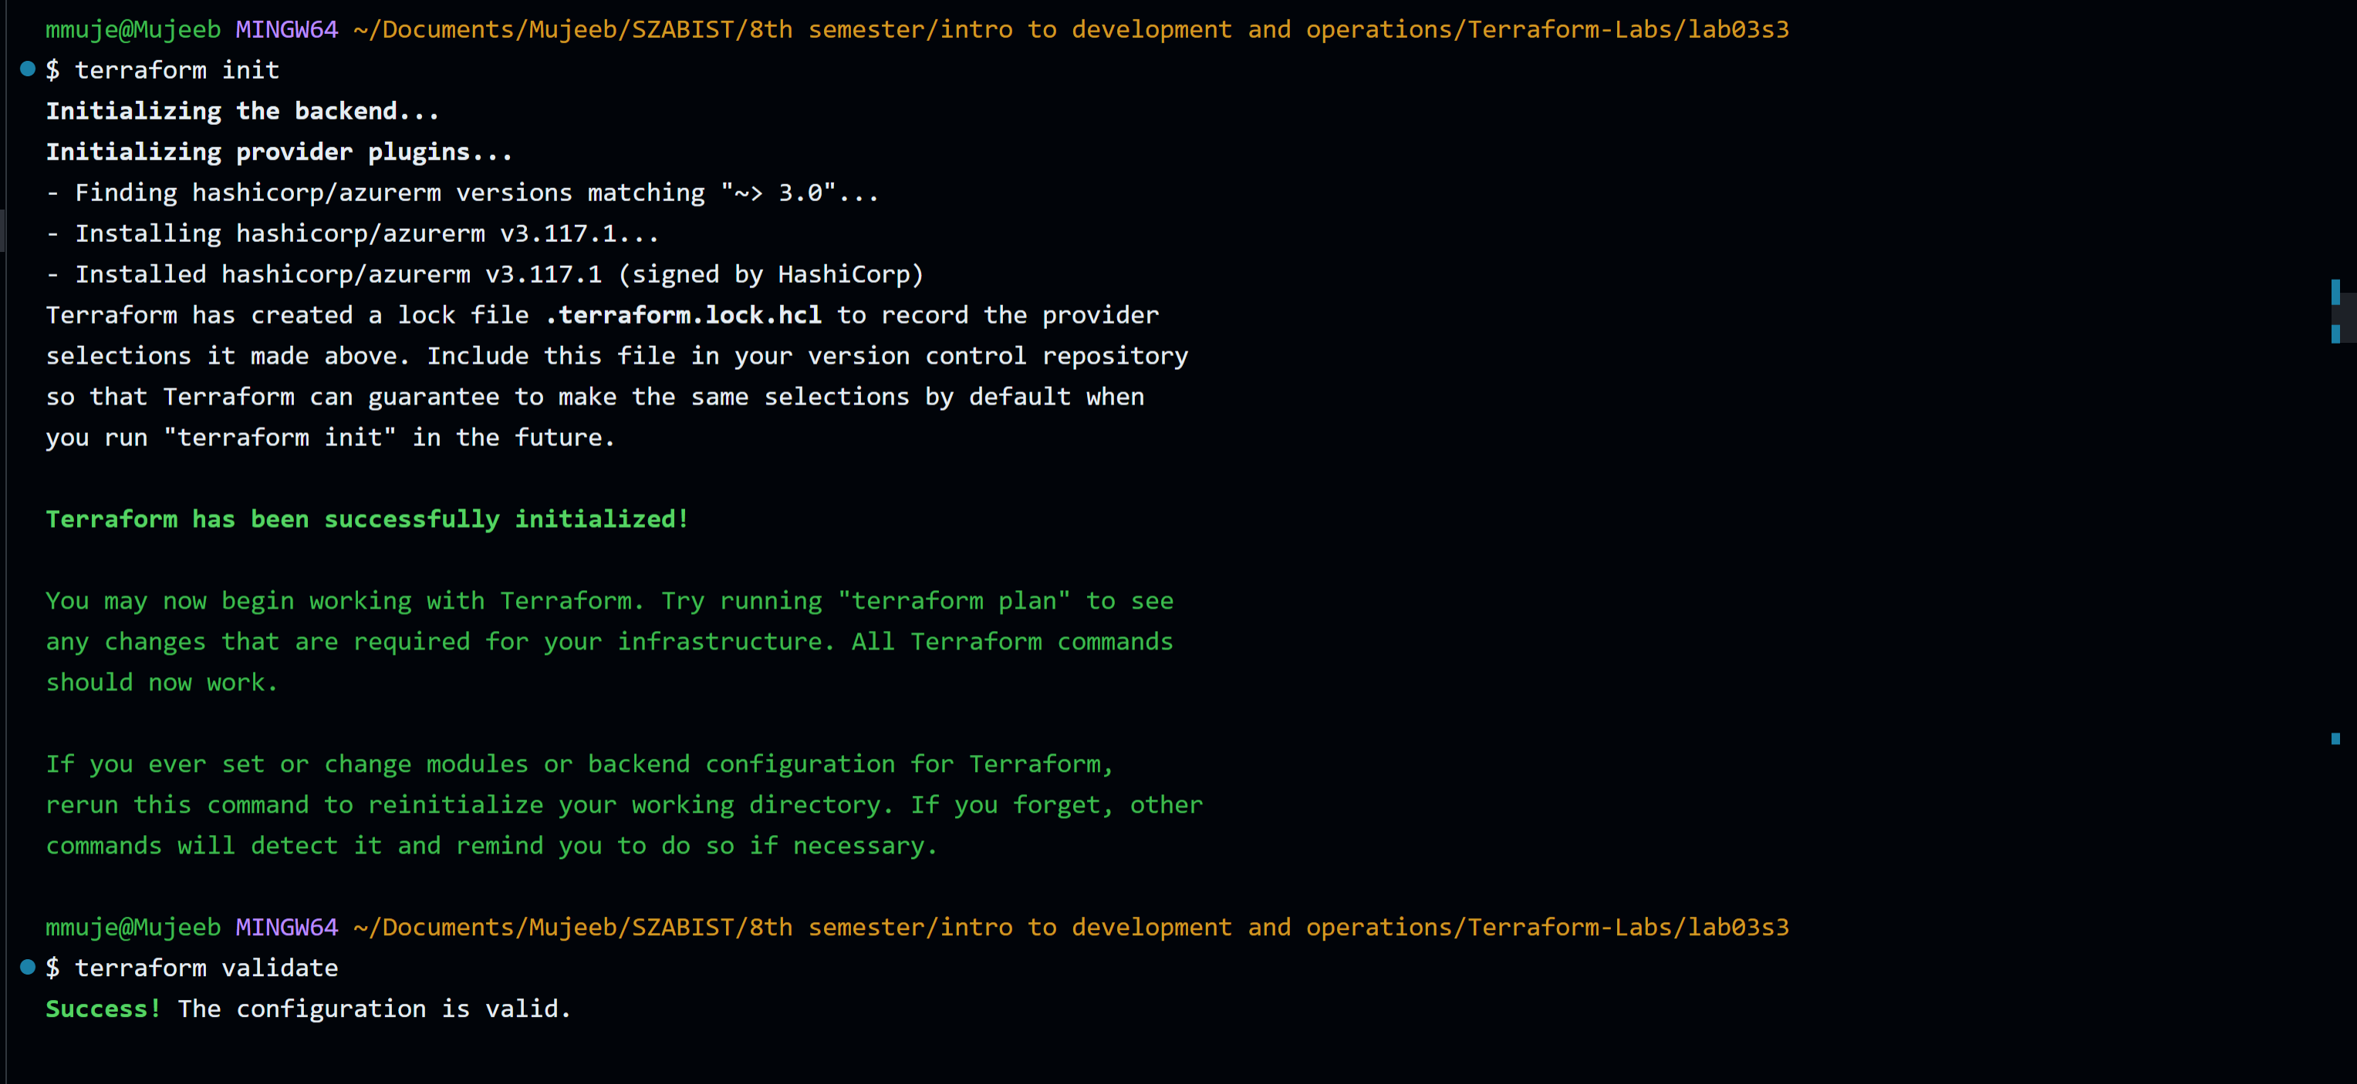

Part 6: Run Simulation
Part 7: Deploy Infrastructure
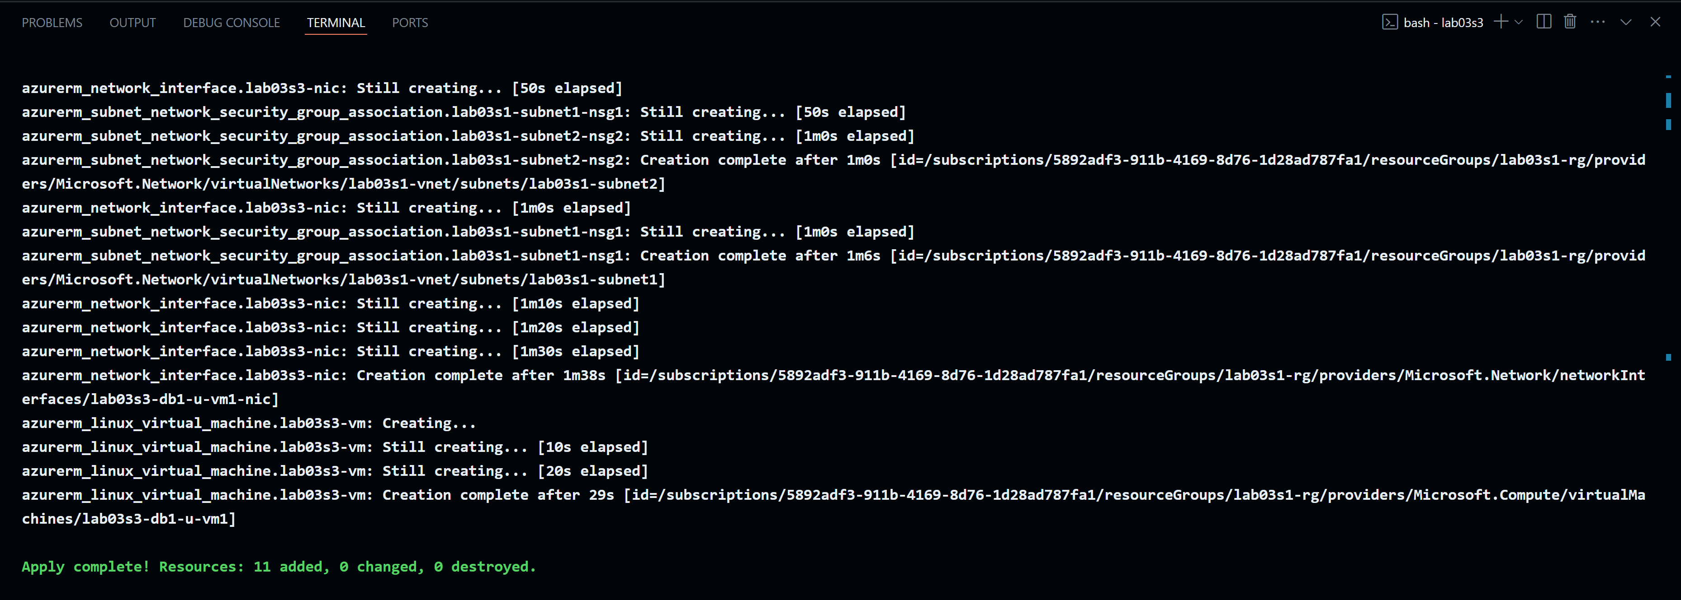
Part 8: Get Information from Terraform State
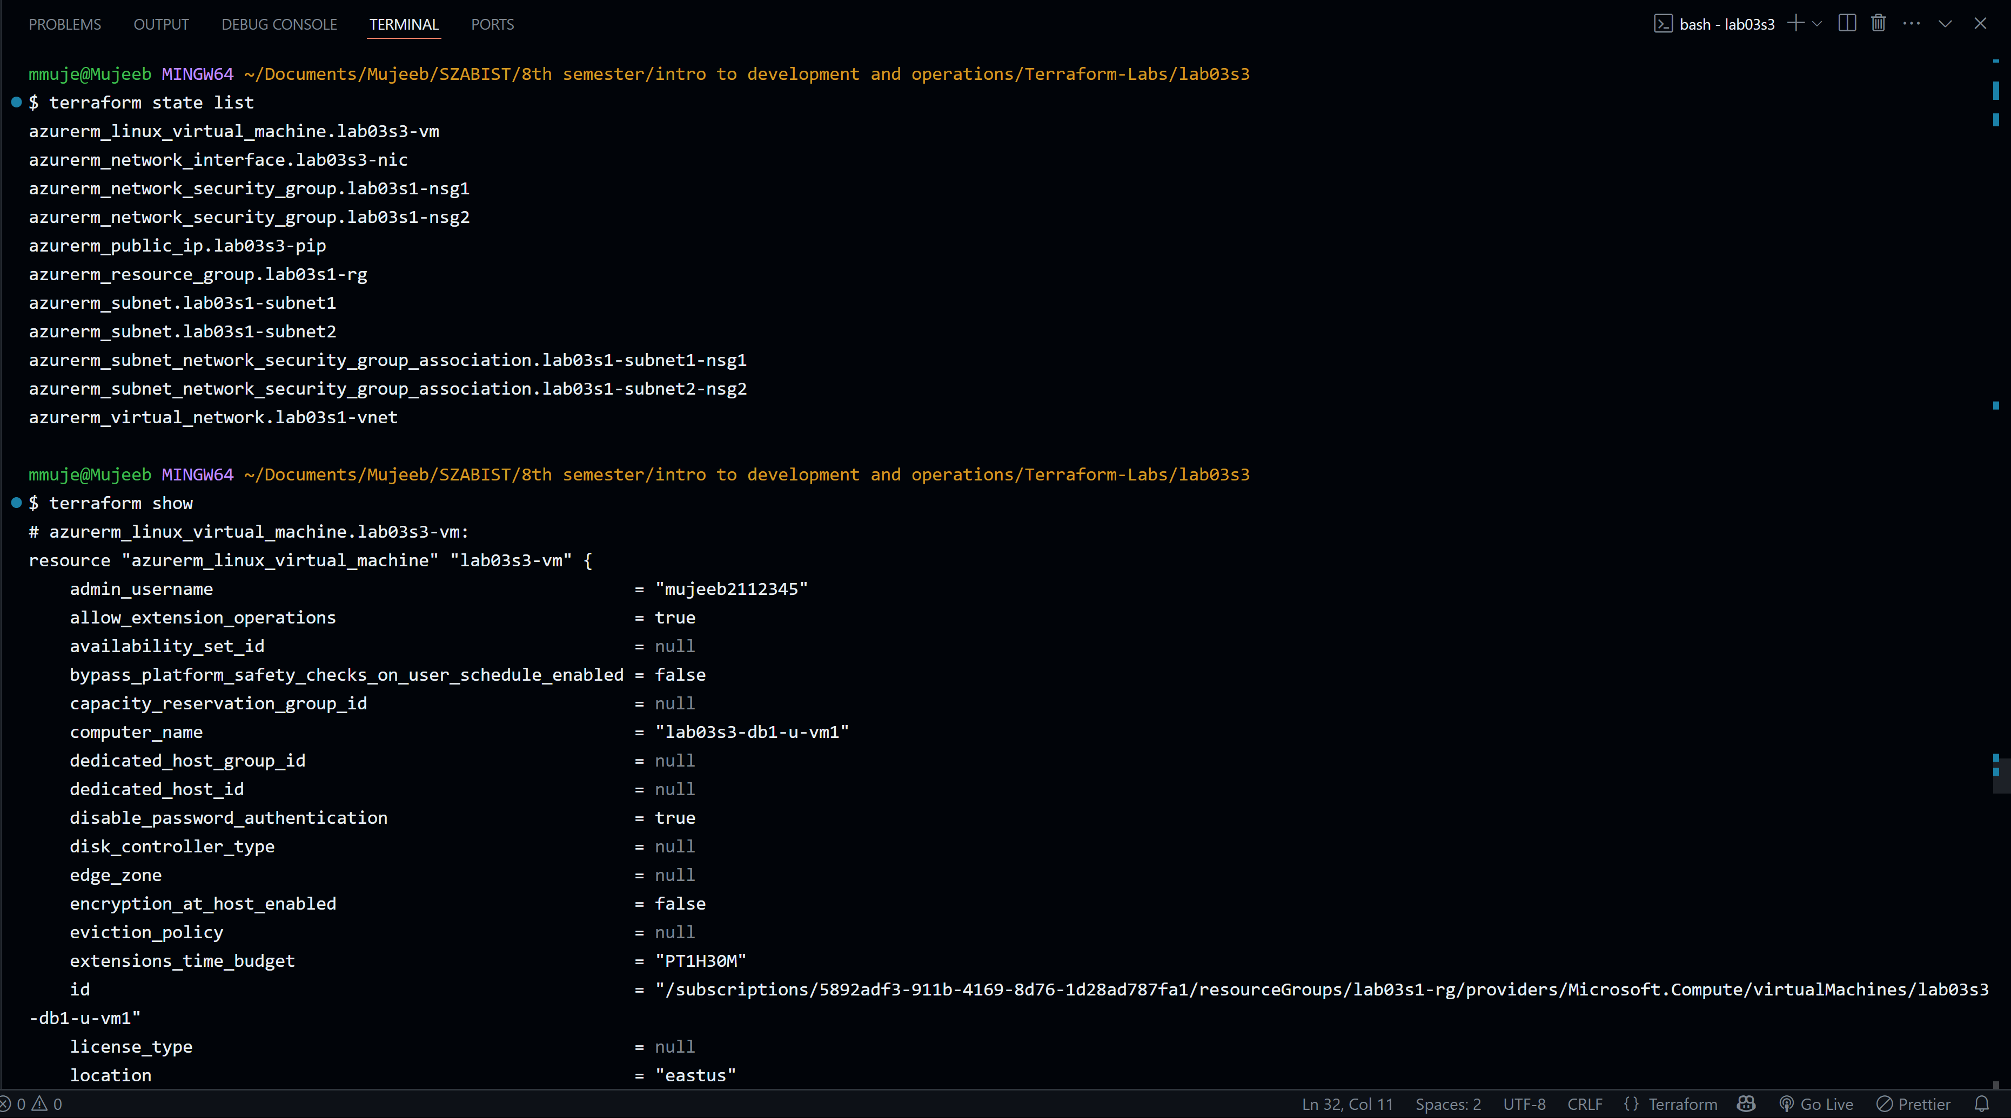
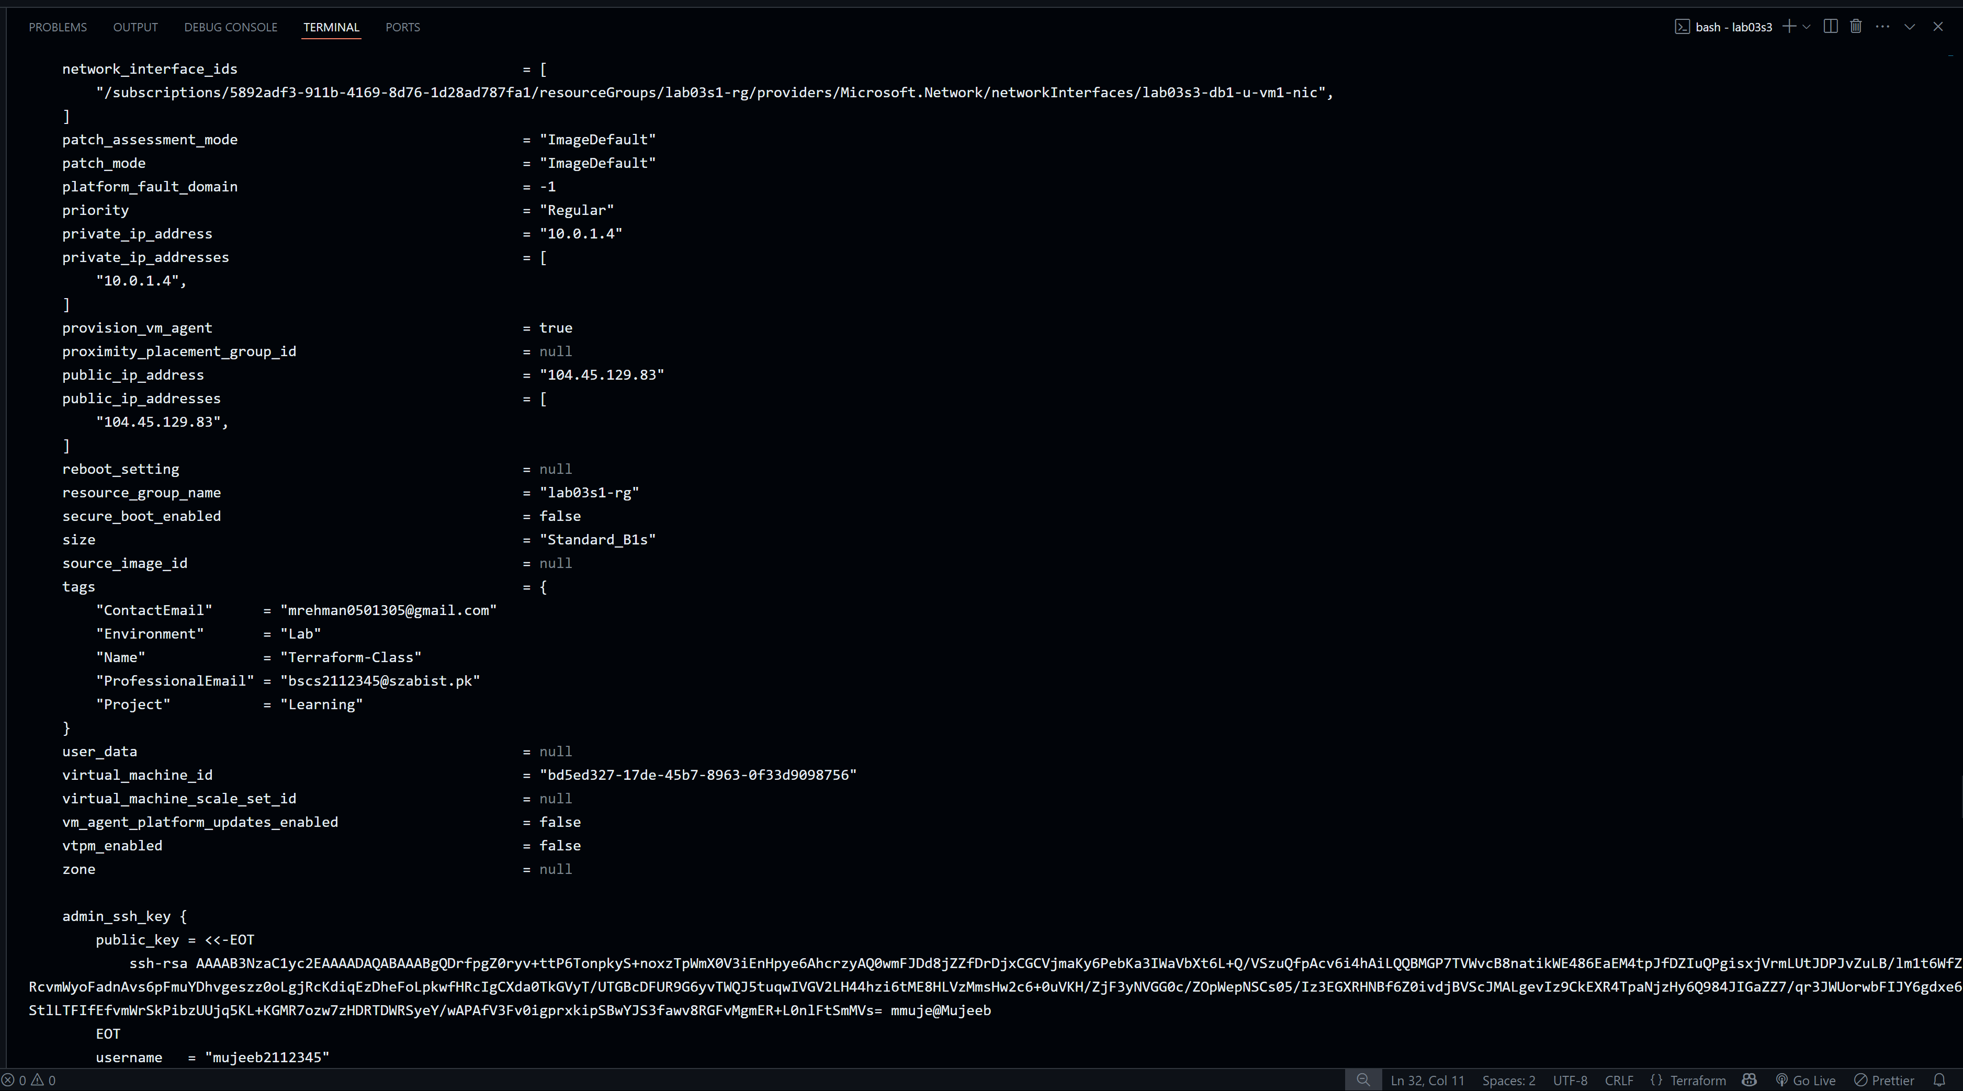
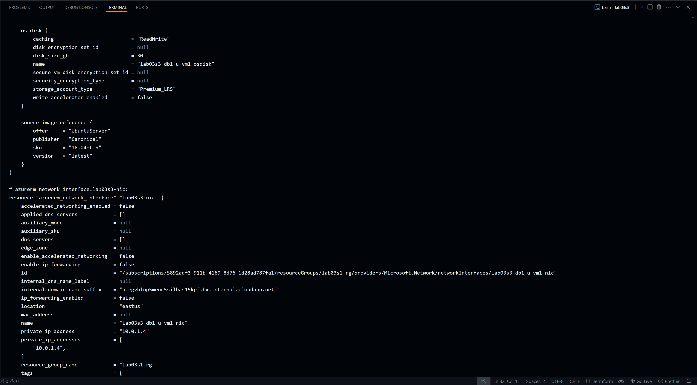
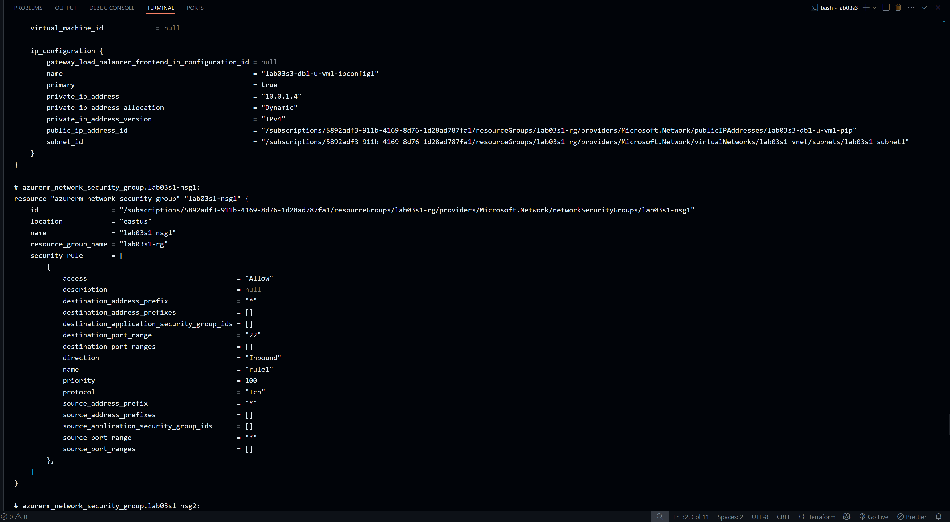
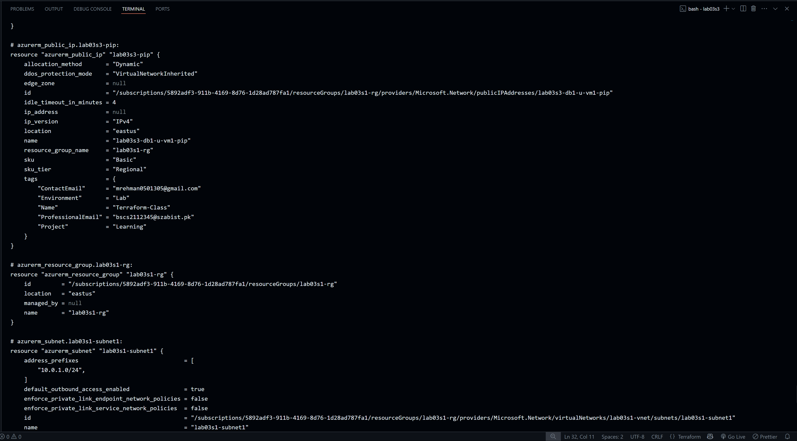
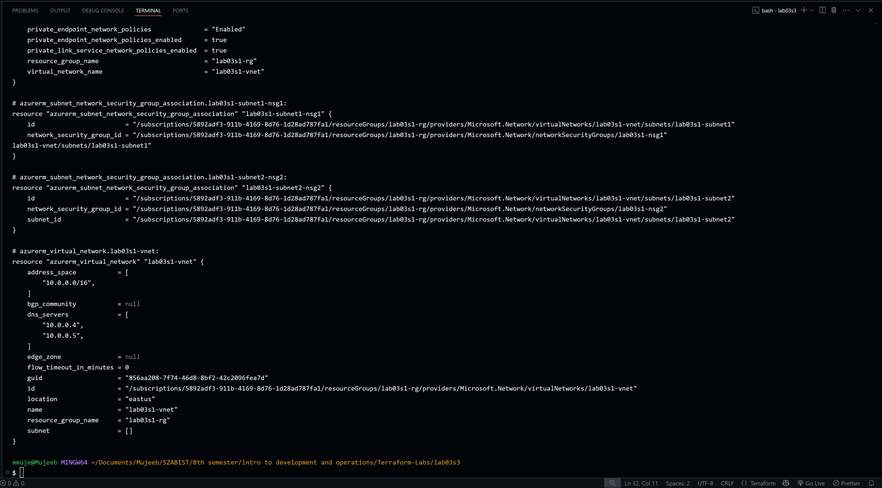
Part 9: Confirm Resource Creation in Azure
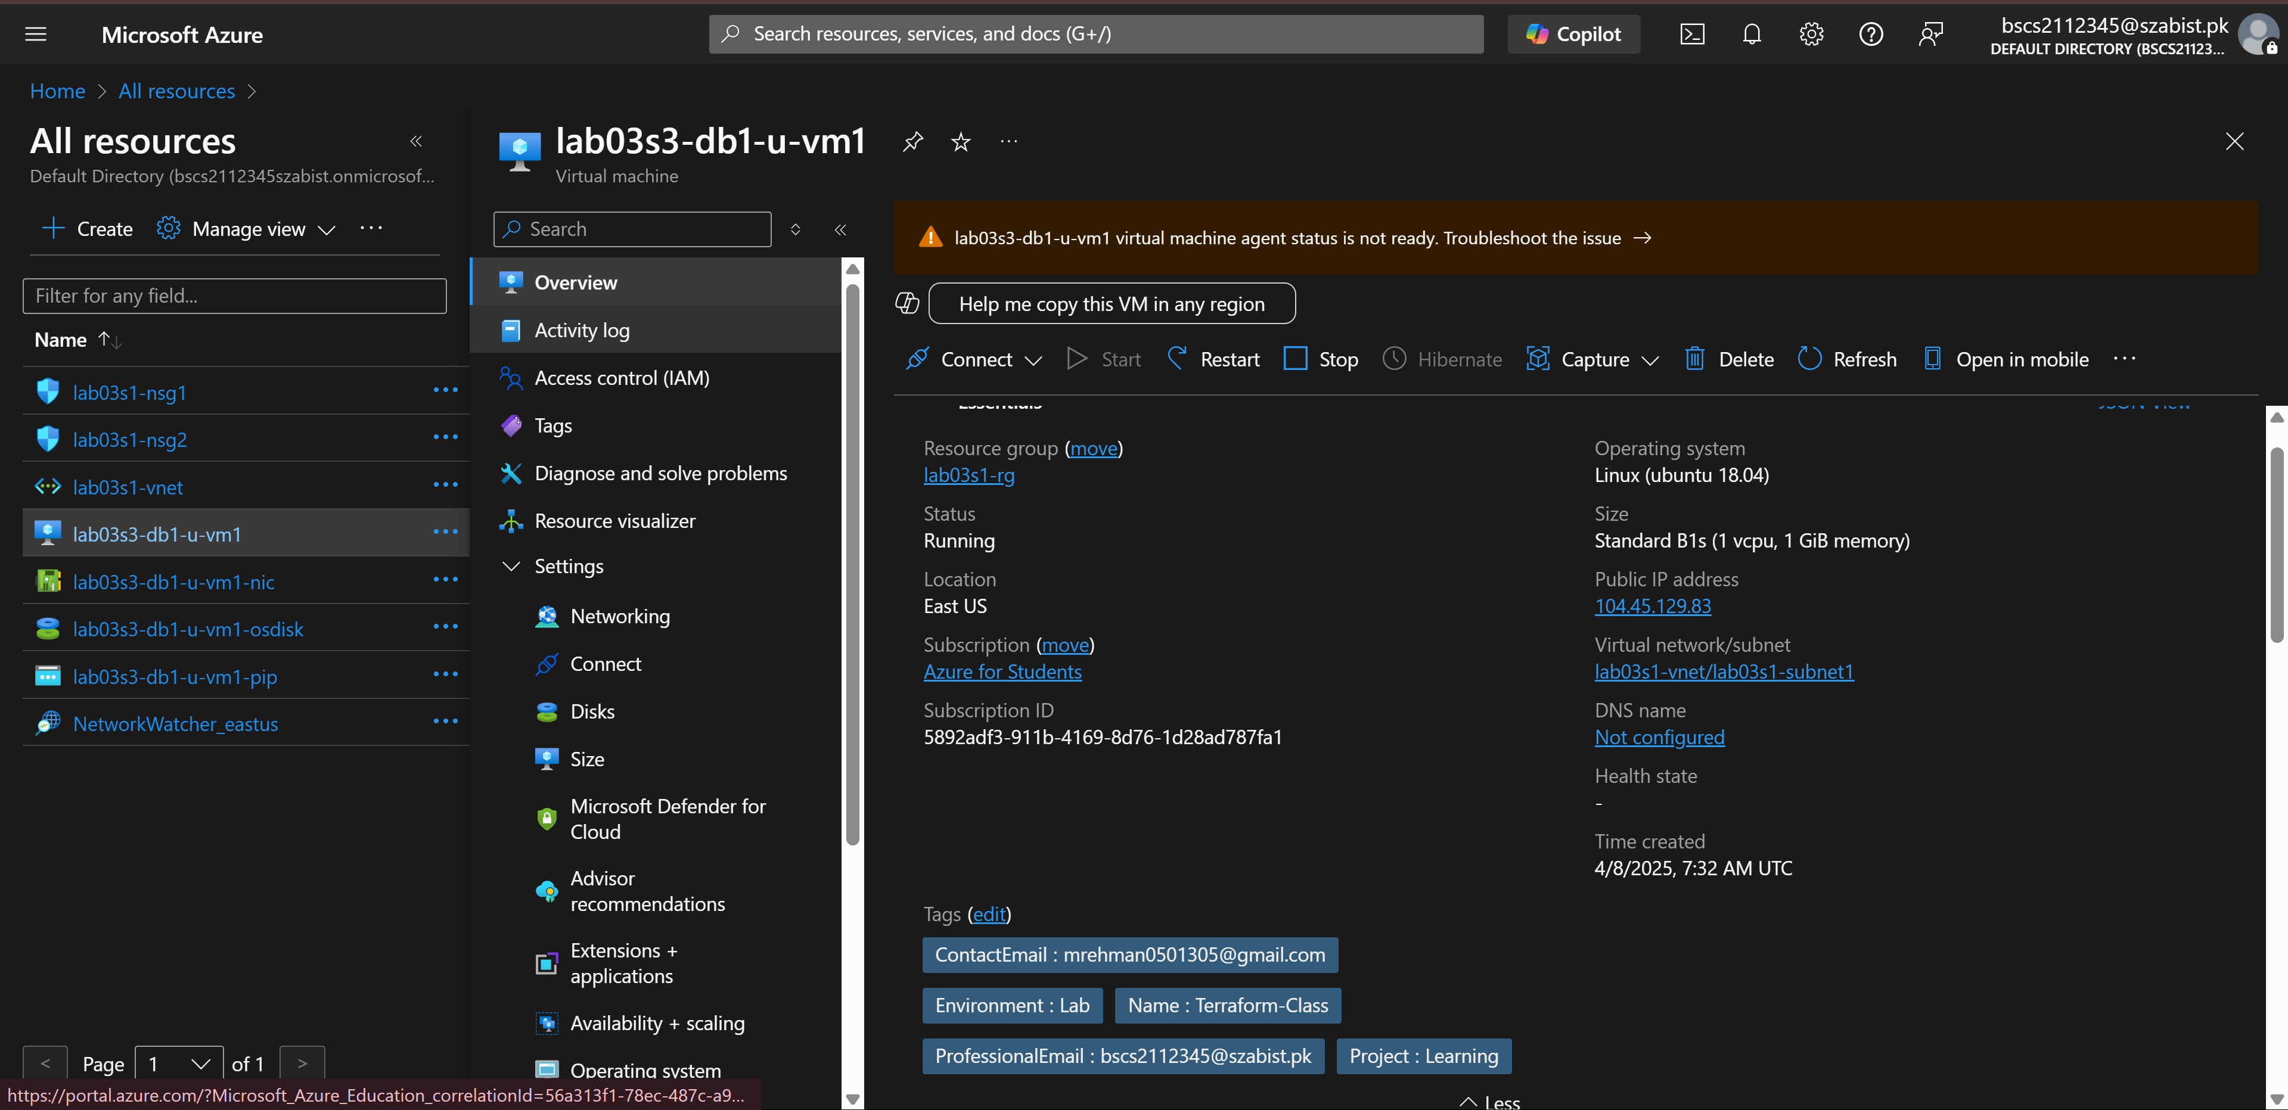
Part 10: Destroy All Resources and Verify
